|  |  |
| --- | --- |
|  |  |

Master’s Thesis

Technische Hochschule Deggendorf

Fakultät Elektro- und Medientechnik

Studiengang Elektro- und Informationstechnik

**Übergang zwischen öffentlichem Netz und Mikronetz mit Energiespeichersystem**

**Elektrisches Design und Software-Implementierung in OpenEMS**

**Transition between public grid and microgrid with energy storage system**

**Electrical design and software implementation in OpenEMS**

To obtain the academic degree:

Master of Science (M.Sc.)

Submitted by:

Supervisor:

Huseyin Sahutoglu

Prof. Dr.-Ing. Otto Kreutzer

Deggendorf, den 14.04.2021

# Eidesstattliche Erklärung

Name des Studierenden: Huseyin Sahutoglu

Name des Betreuers: Prof. Dr.-Ing. Otto Kreutzer

Thema der Masterarbeit: Micro Transition between public grid and microgrid with energy storage system, Electrical design, and software implementation in OpenEMS

1. Ich erkläre hiermit, dass ich die Bachelorarbeit selbstständig verfasst, noch nicht anderweitig für Prüfungszwecke vorgelegt, keine anderen als die angegebenen Quellen oder Hilfsmittel benutzt sowie wörtliche und sinngemäße Zitate als solche gekennzeichnet habe.

Deggendorf, den 30.10.2020 Unterschrift d. Studierenden: __________________________

1. Ich bin damit einverstanden, dass die von mir angefertigte Bachelorarbeit über die Bibliothek der Hochschule einer breiteren Öffentlichkeit zugänglich gemacht wird.

Ja  Nein

Ich erkläre und stehe dafür ein, dass ich alleiniger Inhaber aller Rechte an der Bachelorarbeit, einschließlich des Verfügungsrechts über Vorlagen an beigefügten Abbildungen, Plänen o.ä. bin und durch deren öffentliche Zugänglichmachung weder Rechte und Ansprüche Dritter noch gesetzliche Bestimmungen verletzt werden.

Deggendorf, den 30.10.2020 Unterschrift d. Studierenden: __________________________

Bei Einverständnis des Verfassers mit einer Zugänglichmachung der Bachelorarbeit vom Betreuer auszufüllen:

1. Eine Aufnahme eines Exemplars der Bachelorarbeit in den Bestand der Bibliothek und die Ausleihe des Exemplars wird

befürwortet  nicht befürwortet

Deggendorf, den 30.10.2020 Unterschrift d. Betreuenden: __________________________

Contents

I. Eidesstattliche Erklärung II

II. Abbreviations 8

1 Introduction and Motivation 9

1.1 The Company FENECON GmbH 9

1.2 Objectives 10

2 Background 11

2.1 Characteristic parameters of a storage system 11

2.1.1 Capacity 11

2.1.2 State of Charge 12

2.1.3 State of Health 13

2.1.4 The C-Rate 13

2.1.5 Allowed Charge-Discharge Power 14

2.2 Introduction to OpenEMS 14

2.3 The Modbus-Protocol 15

2.3.1 Modbus RTU 15

2.3.2 Modbus TCP 16

2.4 Grid connection status detection 16

2.5 State of the Art 19

3 Hardware and Software design 20

3.1 Stationary storage system 20

3.2 The inverter 21

3.3 The FEMS 22

3.4 Evaluation of suitable switching devices 23

3.5 Circuit design 28

3.6 Software implementation 34

3.6.1 Software architecture 34

3.6.2 Terminology 35

3.6.2.1 OpenEMS Component 35

3.6.2.2 Nature 36

3.6.2.3 Architecture 37

3.6.2.4 Controller 37

3.6.2.5 Scheduler 38

3.6.2.6 Online Monitoring 38

3.6.2.7 Apache Felix Web Console 40

3.6.3 Software implementation 41

3.6.4 Establishment of data monitoring 52

3.6.4.1 Load and run the OpenEMS on the FEMS 52

3.6.4.2 Basic Apache Felix web console configurations 54

3.6.4.3 Configuration for the OpenEMS backend and OpenEMS UI 60

3.6.4.4 Other controller configurations 61

4 Evaluation and test 63

5 Summary / conclusion / outlook 76

References 77

**List of Figures**

Figure 1 Overview of the capacities of a battery 11

Figure 2 Voltage over SOC according to nominal capacity [1] 13

Figure 3 Classification of the grid connection status detection methods 17

Figure 4 Wiring of the storage system 20

Figure 5 Sinexcel PWS2-30K-EU-HM 21

Figure 6 Compulab IOT-GATE-iMX7 - Industrial IoT Gateway [6] 22

Figure 7 ES-U-2001-STB from EasySync Limited [8] 22

Figure 8 Wago 750-362 Modbus TCP/UDP Fieldbus Coupler [9] 23

Figure 9 4-channel digital input; 24 VDC; 3 ms; 2-conductor connection [9] 23

Figure 10 4-channel digital output; 24 VDC; 0.5 A; 2-conductor connection [9] 23

Figure 11 ABB E 236 undervoltage monitoring relay [10] 24

Figure 12 Schneider Electric RM17UB310 Modular 3-phase voltage control relay [12] 24

Figure 13 ELTAKO AVZ12DX-UC, Zeitrelais 1 Wechsler potenzialfrei 10A/250VAC [14] 25

Figure 14 Schneider Electric A9C20884 ICT 100A 4NO 220...240V 50Hz contactor [15] 25

Figure 15 ABB ESB25-31N-01 Installation Contactor [16] 26

Figure 16 Siemens LOGO!POWER 24 V / 1.3 A Stabilized power supply input [17] 26

Figure 17 ABB F204 A-63/0,3 Residual Current Circuit Breaker [18] 27

Figure 18 ABB S203-B10 Miniature Circuit Breaker - S200 - 3P - B - 10 ampere [20] 27

Figure 19 ABB's OTM63F4CMA24D automatic transfer switch 28

Figure 20 ABB's OMD800E480C-A1 automatic control unit 28

Figure 21 Simple circuit design illustration 29

Figure 22 Terminals for costumer (bottom row) 29

Figure 23 Under voltage detection and main relay 30

Figure 24 Start point for emergency power. 30

Figure 25 24V power supply and battery 24V connection 31

Figure 26 DC supply control 31

Figure 27 Device communication connections 32

Figure 28 FEMS communication 32

Figure 29 Wago fieldbus input channels 33

Figure 30 Wago fieldbus output channels 33

Figure 31 OpenEMS System Architecture [23] 35

Figure 32 OpenEMS Edge Architecture [24] 37

Figure 33 Prioritisation of BESS power setpoints 38

Figure 34 OpenEMS UI Live view 38

Figure 35 Online-Monitoring live mode view 39

Figure 36 OpenEMS UI List of factories 39

Figure 37 OpenEMS UI Setup battery component 40

Figure 38 Apache Felix Web Console 40

Figure 39 OpenEMS Edge architecture for Generic Off-Grid ESS 41

Figure 40 Created and used natures with components in Generic Off-Grid ESS 41

Figure 41 Off-Grid Battery Inverter Nature Channels 42

Figure 42 Sinexcel battery inverter implements Off Grid Battery Inverter. 43

Figure 43 Off-Grid Battery Inverter channel mapping in Modbus protocol 43

Figure 44 Get and set methods for off-grid battery inverter nature. 44

Figure 45 Off-grid frequency channel mapping in Sinexcel battery inverter implementation 44

Figure 46 Soft start method 45

Figure 47 Set Inverter On method 45

Figure 48 Set Clear Failure Command method 45

Figure 49 Set Inverter Off method 45

Figure 50 Battery and battery inverter state machine 46

Figure 51 Io Off Grid Switch Configuration 47

Figure 52 Io Off Grid Switch Component Handle Input method 47

Figure 53 Io Off Grid Switch Component Writing Digital Output for main and grounding. 47

Figure 54 Generic Off-Grid ESS state machine 48

Figure 55 Generic Off-Grid state machine GridSwitch state 49

Figure 56 Generic Off-Grid state machine StartedInOnGrid state 50

Figure 57 Generic Off-Grid ESS state machine StartBatteryInverterInOffGrid state 51

Figure 58 Generic Off-Grid ESS state machine StartedInOffGrid state 51

Figure 59 WinSCP program for transferring the JAR file 52

Figure 60 Entering the commands in the Kitty console 53

Figure 61 Kitty SSH tunnel configuration 53

Figure 62 Modbus RTU bridge for battery 54

Figure 63 BMS Soltaro Single Rack Version C battery configuration 55

Figure 64 FEMS systemd network configuration for battery inverter 55

Figure 65 Configured FEMS IP address on eth1 for battery inverter 56

Figure 66 Modbus TCP/IP bridge for battery inverter 56

Figure 67 Battery-Inverter Sinexcel configuration 57

Figure 68 Modbus TCP/IP bridge for Wago fieldbus coupler 57

Figure 69 IO Wago Fieldbus Coupler 750-352 component configuration 58

Figure 70 IO Off Grid Switch component configuration 58

Figure 71 ESS Generic Off-Grid component configuration 59

Figure 72 OpenEMS service debug log in Kitty 60

Figure 73 Configuration of OpenEMS Backend connection 61

Figure 74 Controller ESS Total Discharge configuration 62

Figure 75 Configuration of grid meter 62

Figure 76 Initial state, running in on-grid mode 63

Figure 77 Grid switch state decision maker 64

Figure 78 Start battery in on-grid 64

Figure 79 Battery started in on--grid 64

Figure 80 Start battery inverter in on-grid 65

Figure 81 Starting battery inverter in on-grid 65

Figure 82 Battery inverter started in on-grid 65

Figure 83 System is running in on-grid 66

Figure 84 Stop battery inverter before switch to off-grid mode 66

Figure 85 Stopping the battery inverter before starts in off-grid 66

Figure 86 Battery inverter stopped 67

Figure 87 Battery inverter stopped, and state is undefined 67

Figure 88 Relay switching, and decision mechanism applied in grid switch 67

Figure 89 Battery started in off grid 68

Figure 90 Battery inverter is starting in off-grid 68

Figure 91 System started to operate in off-grid 68

Figure 92 Stop battery inverter before grid while going to on-grid 69

Figure 93 Battery inverter is going to stopped 69

Figure 94 Battery inverter stopped 69

Figure 95 While going on-grid , battery inverter stopped, and state is undefined 70

Figure 96 Before Start the battery inverter, adjust relay position in Grid Switch state 70

Figure 97 Start battery in on-grid 70

Figure 98 Start battery inverter in on grid first state Undefined 71

Figure 99 Battery inverter is starting in on-grid 71

Figure 100 System started to operate in on-grid mode 71

Figure 101 Enum values of off-grid state machine states 72

Figure 102 Battery % runs in off-grid 72

Figure 103 Battery SOC is 4% and stop sequence is triggered 73

Figure 104 Battery SOC is 4% and battery inverter is stopping 73

Figure 105 Re-start of the system when public grid available 74

Figure 106 Target Stop, first state is Undefined 74

Figure 107 Target stop, battery inverter is stopping 74

Figure 108 Stopping sequence battery inverter go stopped state 75

Figure 109 Stop sequence battery inverter stopped 75

Figure 110 Stop sequence battery is stopping 75

Figure 111 The system is shutdown 76

**List of Tables**

Table 1 Modbus RTU typical message frame [1] 16

Table 2 Modbus TCP typical message frame [1] 16

Table 3 Structure of the MBAP header [1] 16

Table 4 Comparison of current islanding detection methods [2] 18

Table 5 FEMS access data 53

# Abbreviations

|  |  |
| --- | --- |
| Abkürzung | Erklärung |
| BMS | Batteriemanagementsystem |
| BYD | Build Your Dreams |
| DC | Direct Current |
| FEMS | FENECON Energie Management System |
| MPP | Maximum Power Point |
| PV | Photovoltaic |
| SOC | State of Charge |
| STC | Standard Test Conditions |
| NDZ | Non-detection Zone |
| DG | Distributed generation |
| PCC | Point of common coupling |

# Introduction and Motivation

It has continuously contributed to the development of sustainable energy sources, including nuclear energy, global warming reduction, limitations, extreme urban weather conditions and air quality changes due to fossil fuel carbon emissions. A global energy change needs to take place when it comes to providing living space for humans and animals in a sustainable way. These and many other issues need as quickly as possible a 100 percent return of oil, which will have to occur sooner or later due to the limited supply of fossil fuels and resources. Therefore, expansion of PV and wind farms is necessary. Due to the reduced feed-in tariff for PV generated electricity, it is becoming more and more interesting and profitable for private PV system operators to consume electricity generated by their systems on site. This aim can be accomplished using energy storage in grid-connected photovoltaic systems and a significant contribution can be made to a decentralized energy supply by feeding the grid with surplus energy. Decentralized energy storage systems can help offset the surplus and loss of energy produced by renewable energy producers to some degree. With smart control software, energy storage systems can provide grid services. For companies already operating a PV system, a stationary storage facility may pay for itself within ten years. With the assistance of the energy storage device, this is only feasible, as the control software avoids power peaks and therefore does not exceed the limit of a more expensive power connection. This is only one of the control features for fixed storage.

The FENECON Commercial Industrial and battery energy storage systems are now mainly used for on-grid applications. As a next step the system should be upgraded by a back-up solution which fits the need of customers for switching from public grid to microgrid and vice versa. Designing off-grid battery storage systems requires additional hardware and software components to enable a safe grid disconnection of public grids and provide functions like black-start capabilities.

This project is focusing on the concept engineering and technical implementation of a suitable hardware and software system, targeting a serial production ready component as extension to the existing technical units, the FENECON Battery Energy Storage Systems.

## The Company FENECON GmbH

Climate change is a constantly controversial issue in politics and business. The origin of this is the constant warming of the earth. One possibility to counteract this choice is a one hundred percent energy transition. The focus of their implementation is on the environmentally friendly generation and use of energy. This is a goal that should be achieved soon in order not to cause irreversible damage to the climate. With this motto, Feilmeier New Energy Consulting (FENECON) was founded in 2011. FENECON sees great potential in energy storage systems, which should also satisfy the dream of self-sufficiency in-house energy. Intelligent storage solutions have always been proven by the young company with all kinds of end-customers. The customer base ranges from private households to specialized wholesalers and energy suppliers. To pave the way for a clean future, the company has long-term partnerships with innovative energy generation, virtual power plants and industry coupling companies. The FENECON team continues to pursue this goal today. As a result, the company has developed the following four main pillars on which storage systems are based:

* **PV Self-Consumption:** With the help of a PV system, electrical energy is stored in the electricity storage system during the day and is consumed overnight. The use of a battery energy storage system stops the electrical meter, which in turn means that no electricity is drawn from the grid.
* **Active energy management:** with active energy management, additional components such as heat pumps and heating rods are used optimally to make local generated energy available to consumers efficiently. This reduces the high cost of electricity and the high load peaks.
* **Grid services:** due to the unpredictable influence of weather conditions, the generation of electricity from renewable energy sources, such as solar and wind, cannot be constant. That is why the need for grid stabilization increases the further progress of the energy transition. FENECON Energy Storage Systems have been specifically designed to provide fast response times and high output power. Storage systems can therefore support the grid operator, for example through primary control reserve, in stabilizing the frequency of the network.
* **Participation in the market:** In contrast to private customers and small businesses, bulk purchasers are billed based on fluctuating prices and peak loads. Storage systems with high input and output power can reduce peak loads and recharging the storage system at a negative electricity price.

Energy storage system consists of the battery modules and the BMS (Battery Management System) which are mounted in the rack. The inverter is purchased from third party companies to remain versatile with the desired efficiency. Both the storage system and the inverter are managed simultaneously by the OpenEMS program. It is open to all via the Internet and is extended and enhanced on a regular basis by FENECON. In addition to storage systems, the company sells PV systems, e-mobility with the storage system division being the main business of FENECON.

* **Photovoltaic:** Projecting and selling photovoltaic systems (PV) promotes the goal of providing 100% environmentally friendly and cheap electricity.
* **E-mobility:** FENECON offer 1 management for 1 charger to be able to charge with access power which depends on the user input, management for multi-charge points to distribute the maximum available power of each grid connection points. FENECON offers two charger, AC charger and DC charger. While electrical vehicle charge station for DC charger is IES-Key watt, AC charger is KEBA.

## Objectives

The purpose of the present work is to design off-grid battery storage systems with additional hardware and software components to enable a safe grid disconnection of public grids and provide functions like black-start capabilities. In order to expand the portfolio of FENECON, a development basis for the Commercial 30/30 energy storage system is developed. In the end, it can be used in small companies, farms, and agricultural areas. FENECON describes the inverter, the electrical storage, the OpenEMS program for controlling the energy storage device and its hardware. Elementary parameters of the electrical storage device must be provided at the beginning of the job. In addition, a grid detection method is required to accompany the implementation of the storage system. The communication interface, which links the individual components to the energy storage device, must be presented. The concept for designing a storage system is discussed in the following sections. The individual components of the energy storage system are presented, and an analysis approach is used. A test report is then drawn up, which tests the operation of the energy storage device and sets the requirements for the Commercial Product Line. After the measurement setup or hardware configuration has been displayed, the inverter must be integrated in OpenEMS, the FENECON control program, in the next chapter. The data generated by the device is then stored centrally, where it can be called back. When all the arrangements have been made, the measurement is carried out and suggestions are made that lead to quality assurance.

# Background

In this chapter, to understand the system in more detail the most important parameters of a stationary storage system are explained at the beginning. Furthermore, grid detection methods to analyse what kind of device will be needed to detect the grid connection status and for development of a product are introduced, which are mainly used in industry and are relevant for this thesis. Then the OpenEMS and its communication interfaces will be explained, as it plays a central role in this thesis.

## Characteristic parameters of a storage system

The explanation of the parameters of the storage system starts at this stage. They define and differentiate stationary storage systems. In addition, they are important for the understanding of the storage system. A storage system is a lithium-ion-based electrical storage system with an inverter that is powered by an energy management system.

### Capacity

In general, the capacity of the electrical storage device defines the amount of charge that can be contained in the storage cells. The SI unit for the sum of the charge is given in Ah. Multiplied by the nominal voltage UN results in the Wh unit, with a definition of the electricity. An additional definition of the energy in the cell is the energy that relates to the mass of the cell (Wh/g) and the energy density that relates to the volume (Wh/m3). There is also a distinction made between various types of capacity. The maximum power of the Cmax that can be drawn is the amount of charge that can be provided by a fully charged battery. When the battery comes out of output, the Cmax capacity is equivalent to the CN nominal capacity [2]. Full capacity declines only through the ageing of the calendar and the number of charging and discharging periods. With the removable power C, the volume of charge is released from the battery at any current and temperature value chosen until the final discharge voltage is reached [2]. The CN nominal capacity of the battery defines the capacity specified under nominal conditions [2]. The nominal condition defines the nominal IN current and the nominal TN temperature and can therefore no longer be chosen arbitrarily. Capacity loss describes the actions when the battery can accept or releasing a smaller volume of charge due to ageing. The ageing status is defined by the "State of Health" (SOH) parameter and given in percent, in which the ageing of the calendar and the number of cycles have an effect. The following figure clearly demonstrates the functions of the types of capability.

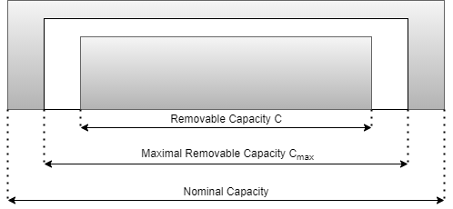

Figure 1 Overview of the capacities of a battery

For the storage system to reach a long service life and thus a high number of cycles, the cells are not charged or discharged outside the limits. For this reason, the "Depth of Discharge" parameter, which is designed to ensure a long service life for lithium-ion-based storage cells, is presented. It defines the ratio of nominal capacity C to maximum usable capacity Cmax, which is expressed in percent. In the case of a stationary storage facility, the upper and lower capacity limits of the nominal capacity are not reached to ensure sustainable service.

### State of Charge

The "State of Charge" defines the current charging condition of the battery and is given as a percentage. As a result, a fully charged battery has a SOC of 100 percent. The SOC value can, in theory, be determined using the formula:

$SOC=\frac{C}{Cmax}*100$ (2.1)

Since equation 2.1 does not consider the SOC value in the past or the time factor, it is not reliable for the battery. Because the SOC value indirectly has the task of protecting the battery from possible deep discharge and from overcharging. The following three approaches have emerged to assess this value reliably:

**Coulomb-Counting Method**

The calculated current is combined with this approach over time. To prevent an offset error, the amount of charge SOC0 already present must also be identified.

$SOC={SOC}_{0}+ \frac{1}{C_{N}} \int_{t_{o}}^{t_{0+t}}{I_{DC}dτ}$ (2.2)

There is little computational effort due to the simplicity of the algorithm. This is a great benefit of the Coulomb system of counting. There is, however, an integration flaw since it does not take self-discharge into account. Periodic calibration steps are required to compensate for the error [3]. These steps can be applied, for example, during the resting-tension process.

**Measurement of the Open-Circuit-Voltage**

Another way to calculate the SOC value is by calculating the open circuit voltage (OCV) of the battery. It represents the charging status of the battery and an algorithm is used to assess the charging status. Since the open circuit voltage and the SOC value are almost linear in relation to each other, this method works. With the following equations, the open-circuit voltage or the charging status can be calculated very easily.

$U_{ocv} = U_{100}*SOC\left(t\right)+ U_{0}$ (2.3)

$SOC\left(t\right)= \frac{U_{ocv}\left(t\right)- U_{0}}{U_{100}}$ (2.4)

$U_{ocv}\left(t\right)$ defines the open-circuit voltage of the battery, SOC $\left(t\right)$ represents the state of charge in percent, U0 is the open-circuit voltage at SOC = 0 percent, and U100 is also the voltage at SOC = 100 percent. For this approach, the very simple determination of values is beneficial. However, to achieve a reproducible result, the load must be decoupled while calculating the non-load voltage. Therefore, this approach does not operate during the process. Further drawbacks are that the ambient temperature is not taken into account and that the relationship between the open circuit voltage and the SOC at the charging limits is extremely non-linear. Figure 2 Voltage over SOC according to nominal capacity [1] shows the non-linearity of the boundaries.

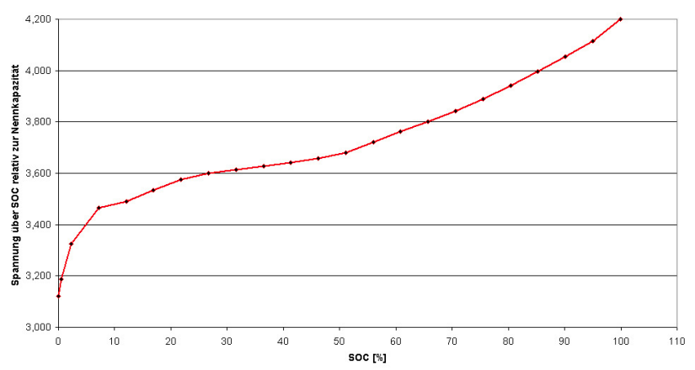

Voltage over SOC according to nominal capacity

Figure 2 Voltage over SOC according to nominal capacity [1]

The SOH value is another important parameter. It describes the current quality of the cells that essentially determine the power. The presentation will take place in the following segment.

### State of Health

Due to various aging effects, the cells and therefore the battery lose their power. One consequence is that the chemical reactions in the cells increase when the ambient temperature is high. This lead, in turn, to a loss of capacity. In addition, internal resistance increases and thus decreases performance [5]. This loss of capacity can be represented using the State of Health (SOH) which is determined from the Cmax maximum capacity quotient and the CN nominal capacity.

$SOH = \frac{C_{max}}{C_{N}}*100$ (2.5)

SOH is given in percent, with 100 percent being a new battery and 60 percent being an unusable battery due to a high safety risk. Electrical car batteries are rejected at a SOH value of 80 per cent because they no longer maintain the range of the car [2]. In addition to the SOH value, the C rate is a fixed parameter. This is set out in the following section.

### The C-Rate

With the C-rate, charging and discharging currents are given in uniform form to make batteries of different capacities comparable. It represents the time it takes until, for example, the battery is discharged. Essentially, the C-rate is formed from the quotient of power and energy or current and the sum of charge. The resulting SI unit shall be $1/h$.

$C = \frac{P_{DC}}{E_{N}} = \frac{I_{dc}}{C_{N}}$ (2.6)

In general, the C rate is given in percent or the estimated factor n is given as C (i.e., $\frac{1}{2}$ C; 1C; 2C; etc.). For example, for a battery with a nominal capacity of $C_{N} =10 Ah$ and a rate of C of 0,5 C, the current $I_{DC}=5 A$. To maximize the service life of stationary storage systems, no C-rate of more than 100 per cent is achieved. They are always possible. This precaution increases the service life of the cells, as the chemical reactions to charge separation inside the cells proceed more slowly and thus create less waste heat. With this measure, the SOH value is lowered more slowly. The parameters presented are controlled by the battery management system. This part will be introduced next.

### Allowed Charge-Discharge Power

Given the amount of energy contained in lithium-ion batteries, as well as their chemistry, etc., certain restrictions are needed to properly charge or discharge the batteries in order to avoid harm and risk. It is usually specified by the battery manufacturer and the maximum current value is chosen as approximately 0.5C to avoid excessive discharge rates that will harm the battery or reduce its power. The maximum current value varies depending on the capacity of different Li-ion batteries. The permissible charge current decreases as the state of charge increases, depending on the power. The maximum charge current sets an upper limit on the charge current that can be used regardless of the load state. A battery with a maximum charge rate variable of 350 Ah and a charge rate of 0.4 A / Ah, for example, could accept a charge current as high as 350 Ah * 0.4 A / Ah = 140 A. To avoid this, restrict the maximum charge current variable to 25 A. There will also be maximum charge voltage and minimum discharge voltage limits in order to safety reasons. Thus, the power to be adjusted in the event that the battery is charged or discharged by the battery inverter will be determined by the allowed charge-discharge power values. The maximum charge current and voltage are multiplied to determine the allowed charge power, while the minimum discharge voltage and maximum discharge current are multiplied to determine the allowed discharge power. As a result, the lithium-ion battery technology to be used is dependent on the inverter to be used and plays a significant role in the overall energy supplied to loads.

## Introduction to OpenEMS

OpenEMS is a modular energy management application. It has been developed taking into account the requirements for monitoring, controlling and integrating energy storage systems along with renewable energy sources and complementary equipment and services such as electric vehicle charging stations, heat pumps, electrolysers, flexible electricity tariffs and more. It is used to monitor the components of the energy storage device and is located locally at the stationary storage facility. This is a definition of the OpenEMS Edge. Depending on the configuration of the energy storage device components implemented, algorithms can be implemented in the OpenEMS Edge.

* which optimizes self-consumption,
* finds the cheap electricity tariff,
* integrates the producers (e.g., PV system),
* integrates controllable consumers (e.g., e-cars) and
* provides grid stabilization and peak shaving services.

The collected data is encrypted and sent over the Internet to the OpenEMS backend running on the server. This enables FENENCON employees to perform on-line maintenance and monitoring of individual energy storage systems. OpenEMS UI is the user interface in the browser or smartphone, which displays data from the energy storage system in a user-friendly manner in real time. The implementation of the component generally deals with the reading of the component registers and, with the help of the algorithms implemented, makes the decision, for example, to stop charging or unloading the battery so that it does not result in overloading or deep discharge. To be able to control these components, used communication protocol is Modbus protocol. Modbus RTU and Modbus TCP have already been implemented in OpenEMS. The following subsection introduces the Modbus protocol and its interfaces for communication.

## The Modbus-Protocol

The Modbus protocol was developed in 1979 by Modicon (Schneider) based on a master/slave structure [8]. With this protocol, a master can interact with a few slaves. The master initiates contact, and the slaves respond in response. In addition, the Modbus protocol uses functional codes to ensure supervised communication. The table in Appendix X, Table X offers a simple description of all the Modbus protocol feature codes. The feature codes used must be issued by the manufacturer for communication with the system. Communication paths for Modbus RTU and Modbus TCP are also available. These are explained in more detail in the sections below. The Modbus protocol was developed in 1979 by Modicon (Schneider) based on a master/slave structure [8]. With this protocol, a master can interact with a few slaves. The master initiates contact, and the slaves respond in response. In addition, the Modbus protocol uses functional codes to ensure supervised communication. The feature codes used must be issued by the manufacturer for communication with the system. Communication paths for Modbus RTU and Modbus TCP are also available. These are explained in more detail in the sections below.

### Modbus RTU

The acronym RTU stands for Remote Terminal Unit and defines data traffic on a serial bus. With a serial bus, the bits are transmitted one by one in the form of telegrams. Popular serial bus systems are RS-232 or RS-485, for example. The data is unipolar with RS-232 and differential with RS-485.

Table 1 Modbus RTU typical message frame [1]

|  |  |  |  |  |  |
| --- | --- | --- | --- | --- | --- |
| Start | Address | Function | Data | CRC | End |
| 3.5 Char time | 8 Bit | 8 Bit | N * 8 Bit | 16 Bit | 3.5 Char time |

There is a delay of at least 3.5 characters between frames, each character being 8 bits long. This is accompanied by a system slave ID to ensure a specific assignment. The communication partners know, through the function code, what the objective of the system should be. The data area contains the actual details of the users.

### Modbus TCP

This version is subject to the Modbus protocol and the Transmission Control Protocol (TCP/IP) protocol. The data is thus distributed in the form of packets. The network participants are identified via IPv4 addresses. Port 502 is reserved for communication via Modbus TCP.

Table 2 Modbus TCP typical message frame [1]

|  |  |  |
| --- | --- | --- |
| MBAP Header | Function | Data |
| 7 Byte | 1 Byte | N * Byte |

As with Modbus RTU, in addition to the data, the function codes are given through functions. The Modbus Application Protocol Header (MBAP) is also included in the Modbus TCP framework. A further breakdown of the MBAP header is shown in.

Table 3 Structure of the MBAP header [1]

|  |  |  |  |
| --- | --- | --- | --- |
| Transaction ID | Protocol | Length | Unit ID |
| 2 Byte | 2 Byte | 2 Byte | 1 Byte |

The transaction ties with the respective participant are passed to the transaction ID. The requested participant shall respond with the same transaction ID. The protocol type is transmitted with the protocol ID. This is zero with Modbus. The length of the data would then be transmitted to the contact partner. Unit ID shall be set to one for direct contact with the Participant, as the address is made with the IP address. Modbus TCP has various topologies, with the star topology being the most widely used switch.

## Grid connection status detection

Since the inverter will act as an off-grid generator in this project, it is important to re-establish the current electricity grid when it is commissioned to accommodate the additional power to be brought into operation. In this respect, it is important to include distributed generation systems with bi-directional energy flow in the existing power system instead of the current one-way energy flow. The identification of island mode operation is one of the most important problems faced in incorporating distributed power generation systems into the existing electricity grid. In this section, the characteristics of the system to be used to decide the status of the grid connection, why it is preferred, will be addressed following a comparison of the current methods, the advantages, and disadvantages of the methods.

The island operation of the micro grid can be done to run the micro grid connected to the grid without being connected to the grid by transmitting or receiving power from the public utility. If the micro grid is disconnected/disconnected from the grid/mains without the operator's order or awareness, this is called unintentional insulation and may normally be due to any fault in the grid that causes the relays to trip. As this project will be focused on intentional island management, a power management plan must be implemented on a deliberate island generated by DG to ensure consistent local loading. In today's literature, several methods of naming detection are divided into two key methods, local and remote sensing which can also be seen below in Figure 3 Classification of the grid connection status detection methods.

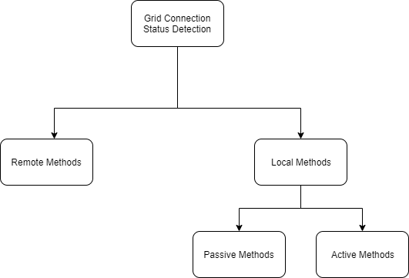

Figure 3 Classification of the grid connection status detection methods

Local methods are based on measurement of some parameters or variables on the microgrid side, including passive methods and active methods. Passive methods directly monitor parameters or variables including voltage, current, frequency and phase to detect islanding. Active methods intentionally inject a disturbance to detect whether it affects voltage, frequency, power, or impedance parameters. Remote methods are based on the communication between microgrid and main grid to monitor breakers immediately.

Communication-based approaches have the highest performance compared with passive and active methods. Thanks to the installation of sensors and telecommunications equipment in the system, all circuit breakers are controlled by the control system, and these methods have high system and operational costs. Communication-based approaches are most also used in high-power systems with critical loads such that the quality of the power does not alter, and the system is reliable. Table 4 Comparison of current islanding detection methods gives detailed information in comparison between local and remote methods.

Whether islanding can be detected accurately, timely and effectively is largely determined by the performance of islanding detection methods, or in other words by the performance of grid connection status detection. These indices consist of non-detection zone, detection time, error detection ratio and power quality.

**Non-detection zone:** Non-detection zone is the main reason why IDMs fail to detect islanding. It should be summarized in different ways according to different categories of islanding detection methods. None-detection zone of methods based on monitoring voltage, frequency or phase deviation is often described in power mismatch space. NDZ of methods based on disturbance injection is usually described in load parameter space.

**Power quality:** Methods based on injecting disturbance can significantly reduce NDZ when detecting islanding. However, it is inevitable for injecting disturbance to distort power output and deteriorate power quality. Power quality is an important index when selecting IDMs.

Table 4 Comparison of current islanding detection methods [2]

|  |  |  |  |  |  |
| --- | --- | --- | --- | --- | --- |
|  | Local Methods | | | Remote Methods | |
| Parameters | Active | Passive | Hybrid | Utility | Communication |
| Operation Principle | Adding a disturbance signal to the grid | Measuring the PCC parameters | A combination of active and passive methods | Small significance impedance installed | Communication between grid and DGs |
| NDZ | Small | Large | Small | None | None |
| Power quality effect | Degraded | No degradation | Degraded but lower than active method | No degradation | No degradation |
| Multiple DGs operation | Not possible | Possible | Possible | Possible | Possible |
| Response time | Shorter than passive method | Short | Longer than active method | Fast | Faster |
| System Cost | Medium | Low | High | Very high | Extremely high |

Passive methods identified and evaluated are as follows:

* Over / Under Voltage
* Over / Under Frequency
* Voltage Phase Jump
* Detection of Voltage Harmonics
* Detection of Current Harmonics

Active detection methods are generally built into the inverter and methods analysed are:

* Impedance Measurement
* Detection of Impedance at a Specific Frequency
* Slip-mode Frequency Shift
* Frequency Bias
* Frequency Jump

Given that the selected device can be used with multiple inverters, the low price and monitoring without impacting network power played a significant role in the device's selection in this project. Also, since the company's device selection was constrained, it had to be the one with the lowest price, so the passive method met all of the requirements. And the approach used was over/under voltage detection because the disadvantages such as response time and no detection zone are minor, and the basic method considered in this project is to check the grid connection by measuring the voltage. The device details selected in accordance with this method are given in section 3.4 Evaluation of suitable switching devices.

## State of the Art

It is planned to introduce a new solution that will help grid selection, reliability, grid stability, use of the energy provided by solar panels, operate regardless of the battery type used or the independent battery inverter and allow different applications. organizing peaks with this project, limiting capacity, and using additional heating elements. The industry's operation in the low voltage range, also called residential photovoltaic system, is about 5 to 20kWh of capacity, and the higher range is in the range of 50kWh to GWh; However, it is difficult to talk about the state-of-the-art technology for this project, as most micro grid applications have not yet been implemented between 20kWh and 50kWh. The applications that the companies want to work on and plan for the sector, in other words, the transition between the public grid and the micro grid, the device capacity, the output power, needs related to the energy storage system will be specified. The flexibility of the inverter or battery used will be compared with the project to be made.

"INTILION's scalebloc 0.5C" has 30kW output power, 68.5kWh versatile energy storage capacity, with 725 V nominal DC voltage, 400V AC voltage for three phase, its own energy management system, and varies from the project in several respects, such as not having flexibility in the choice of battery and battery inverters, and not having flexibility in the transition between public grid and microgrid [3]. Although it has an energy management system and applications such as peak-shaving and self-consumption optimization, it lacks many applications such as balancing, limit total discharge, and delay charge offered by OpenEMS, and it lacks battery safety in an off-grid case. Furthermore, OpenEMS offers the ability to implement such applications for multiple parallel connected battery inverters, so that the battery inverter can be selected as a grid provider in an off-grid state and charge-discharge in an on-grid state in a row or evenly.

Schneider Electric provides the “XW Pro 6.8 / 8.5 kW” hybrid inverter, which includes a generator input port. The key distinction begins with a comparison of the output power, which can be as high as 6kW, and the potential for the XW Pro, which can be as high as 10000A with 240 V AC voltage for 3 phases [4]. Since energy management is not introduced for a problem-free application, the switching mechanism is performed automatically with an automatic transfer switch, and no additional features are provided or implemented other than self-consumption optimization. Besides, this inverter is not available for Europe, designed for North America, operating frequency range is 50 to 60 Hz.

ABB's modular microgrid is compact and has four pre-designed variants in the range of 50 kW to 4,600 kW, to meet varying customer needs and the standard integrated functionalities include grid-connected and off-grid operation with seamless transition, and the customer can choose to configure the microgrid to integrate energy from solar, wind, main grid or diesel generator supply, based on the application and local conditions [5]. The key difference is that the aim of this product is to be built for industrial applications, so applications offered by the energy management system for low-capacity houses and farms are not possible.

As a result, considering existing products, this is a fundamental necessity due to the lack of a product for use at low capacity, and new product creation is needed to enable the transition between the public grid and the micro-grid, taking into account battery safety, and then allowing the integration of diesel generators and PV inverters.

# Hardware and Software design

In this section of the study, the individual components used in this project are provided. It has been developed with the independent feature of the energy storage system defined in FENECON. Individual components, the inverter capacity is 30 kWh, with a corresponding output of 30 kW, the Wago fieldbus coupler to check the relays and learn their current status, and under voltage detection to check network presence. In an off-grid configuration, the ground relay connects the inverter neutral link to the network ground, while the main relay connects the grid to the inverter. And, with the introduction of the extended OpenEMS architecture, a modular platform for energy management applications, an Open-Source Energy Management System (OpenEMS), the terminology and architecture of OpenEMS, off-grid natures and their channels that will be built for the generic off-grid energy storage system will be explained.

## Stationary storage system

The electrical storage from Soltaro is fitted with 10 battery modules and a battery management system. The storage capacity of the module is 90 Ah. Multiplied by a nominal voltage of 38.4 V of the module, this results in a nominal capacity of 3.456 kWh. The total nominal capacity for this configuration is therefore 34,56 kWh, as the storage modules are connected in series. The battery module contains 12 cells which are controlled for voltage and temperature. The cells are lithium-iron phosphate cells with a specific capacity of 100 to 150 mAh/g. The data for voltage and temperature monitoring shall be transmitted to the BMS via the RS-485 bus. The daisy chain topology is used and terminated with a 120 Ω resistor. Figure 4 Wiring of the storage system, demonstrates the wiring on the storage system. The blue lines symbolize the power links and the dotted lines of the RS-485 bus. In addition to power and communication links, the BMS module has a main switch and an electrical start switch. They can be used to enable and disable the storage system. The term BMU defines the battery module or the BMS. With the interface of the Battery Control Unit, cascading with the same storage device is assured. The implementation of the BMS of the electrical storage system in OpenEMS has already been carried out by an employee of the company FENECON, so that all the BMS parameters can already be read or written.



Figure 4 Wiring of the storage system

On the other side, the energy storage system consists of the electrical storage unit and the inverter. This is defined in the section below.

## The inverter

The Sinexcel PWS2-30K-EU-HM inverter has the requisite specifications to operate the storage system. The nominal load and discharge voltage limits are between 200 VDC and 750 VDC with a charge and discharge power of 30 kW. The new limit for charging ad discharging the inverter is 90 A on the battery side. In addition, the second basic requirement is met that the inverter be compatible with the German power grid. The inverter is shown visually in the diagram below.





Figure 5 Sinexcel PWS2-30K-EU-HM

The three-phase power grid system is connected to terminal 1 and 2 and the connection 1 contacts for the grounding conductor are heard. Port 3 is an Ethernet network and port 4 has additional communication interfaces such as CAN and RS-485. Contacts 5 and 6 are for connection to the battery management. The scale of the inverter in Figure 5 Sinexcel PWS2-30K-EU-HM is in millimetre size and corresponds to the normal size of the 19-inch rack. The RJ-45 socket is used for communication with Modbus TCP. The inverter can only turn on when the nominal voltage of the battery is applied to the inverter. With a pre-charge resistor, it belongs to the high inrush current, as the capacitors have a short-circuit current when turned on. After the switch-on moment, the circuit with the relay bridges the resistor of the series and the inverter is ready for use. As this individual part of the energy storage device is used for the first time, it must be included in OpenEMS. For this reason, the possibility parameter table from the manufacturer Sinexcel is used. The table shall become the registers of the inverter. They can be read with the Modbus protocol, and some of them can be written to. The option between Modbus TCP and Modbus RTU remains available. The energy storage system is now in operation. For it to be monitored, the FENECON control program is established on which OpenEMS is being tested.

## The FEMS

The hardware of the FEMS is from Compulab; System-on-Modules are fully featured single board computers designed for integration into custom applications through miniature high-density connectors. Compulab modules are supported with full BSPs and ready-to-run images for Linux, Android, and WinCE. The board is equipped with an Ethernet and a USB interface. The NXP i.MX 7Dual ARM Cortex-A7, 1GHz processor is used as the CPU on the board [6]. The voltage supply is unregulated 8V to 24V. In order for the OpenEMS to run on the FEMS, a JAR file must first be generated. This can be done using the Eclipse programming environment. The file is loaded onto the FEMS using the WIN-SCP software [7].

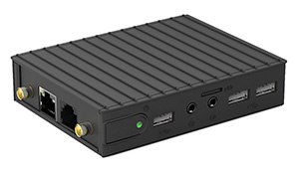

Figure 6 Compulab IOT-GATE-iMX7 - Industrial IoT Gateway [6]

So that the FEMS can communicate with the BMS via the RS 485 bus, an additional component is required that translates the communication from RS 485 to USB and vice versa. The ES-U-2001-STB from EasySync Limited is used for this. With various configurations of the DIP switches, the RS 422 or RS 485 component can be converted to USB with a 4-wire or 2-wire version. The following figure shows the adapter for the RS 485.



Figure 7 ES-U-2001-STB from EasySync Limited [8]

## Evaluation of suitable switching devices

To control the switching devices with main control relay and grounding control relay via the energy management system, as well as to read "under voltage relay" states in addition to the current states of the switching devices, a Wago Model 750-362 fieldbus coupler was used which is also already an implemented device in OpenEMS. The 750-362 Modbus TCP/UDP Fieldbus Coupler connects ETHERNET to the modular WAGO I/O System, and the fieldbus coupler detects all connected I/O modules and creates a local process image and it is designed for fieldbus communication in Modbus networks [9].

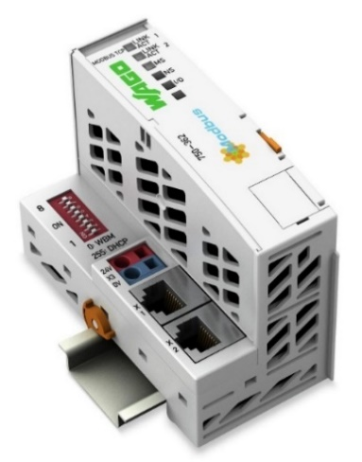

Figure 8 Wago 750-362 Modbus TCP/UDP Fieldbus Coupler [9]

In addition to the Wago fieldbus control unit, a input conductor connection which is shown in Figure 9 4-channel digital input; 24 VDC; 3 ms; 2-conductor connection [9] and a output conductor connection which is shown in Figure 10 4-channel digital output; 24 VDC; 0.5 A; 2-conductor connection [9] are used.

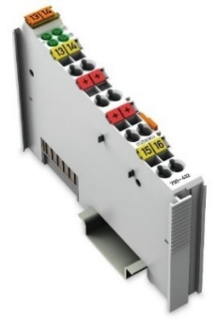

Figure 9 4-channel digital input; 24 VDC; 3 ms; 2-conductor connection [9]

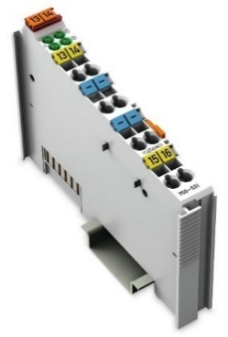

Figure 10 4-channel digital output; 24 VDC; 0.5 A; 2-conductor connection [9]

In the case of a grid failure, it was mentioned that after the inverter is stopped and before ready for off-grid service, or similarly from off-grid to on-grid state transition, it will be accomplished by controlling the Wago output signal by the FEMS in order to bring the contactors to the appropriate position. The system grid connection status detection device, as well as the other contactors and circuit breakers used, will be introduced for further study.

As mentioned in the section 2.4 Grid connection status detection, to detect grid connection status via grid under voltage monitoring, which is a sub-section of the passive method; hence, the device used to detect grid connection status which is also shown in Figure 11 ABB E 236 undervoltage monitoring relay [10]. Its rated voltage is 250 V AC rated, frequency is 48-63 Hz, measuring range supply voltage 3N 400/230V AC and its accuracy in nonchanging environment, setting tolerance is less and equal than five percent, response time approximately 100 ms, it has also 2 signal contactors to be able to get the grid connection status [11]. The green LED is lit when the supply voltage is applied. If each phase voltage exceeds 195 V with respect to the neutral including the hysteresis when switching the device on, the relay switches immediately into the working position. If at least one phase voltage falls below the threshold value, the relay goes back into its normal position and the yellow LED goes out, if also phase 2 fails, the green LED goes out, too, so, it is indispensable to connect the neutral conductor [11].

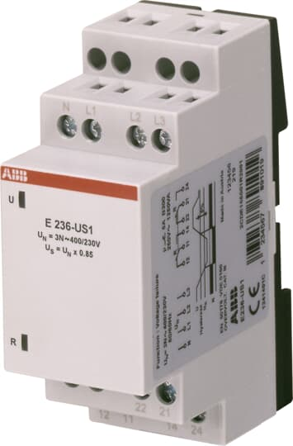

Figure 11 ABB E 236 undervoltage monitoring relay [10]

Alternatively, Schneider Electric company’s RM17UB310 could be selected, also shown in Figure 12 Schneider Electric RM17UB310 Modular 3-phase voltage control relay which has rated voltage 183 V AC rated, frequency is 50-60 Hz, measuring range 183…528 V AC, setting tolerance is less and equal than ten percent, response time approximately 200 ms, in addition to these pros and cons, it has adjustable screws, to set voltage tolerance and switching time delay [12]. However according to those comparison, even though RM17UB310 is a better solution for this application, cost of this device almost double amount of E236-US1. So, this forced the selection to be made by E236-US1.

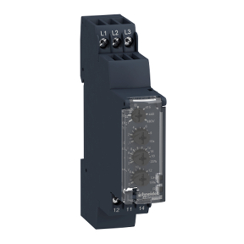

Figure 12 Schneider Electric RM17UB310 Modular 3-phase voltage control relay [12]

According to the technical rules published by VDE Verband der Elektrotechnik Elektronik Informationtechnik e.V. the connection of generating plants and storage to the grid operator's grid may only take place if it is determined by a suitable device that both the grid voltage is within the tolerance range of 85% Un to 100% Un and the network frequency is within the tolerance range of 47.5 Hz to 50.1 Hz for a duration of at least 60s [13]. Thus, although it is implemented in OpenEMS for safety purposes, re-connection from micro grid to public is considered with the insertion of an additional timer, as shown in Figure 13 ELTAKO AVZ12DX-UC, Zeitrelais 1 Wechsler potenzialfrei 10A/250VAC [14].

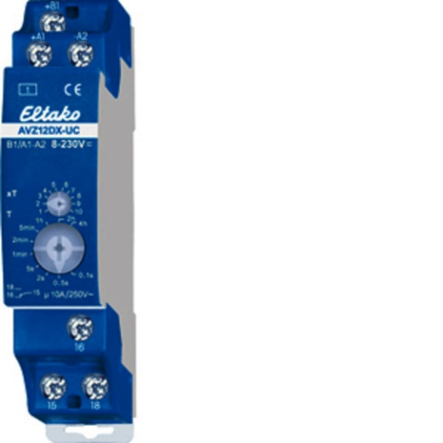

Figure 13 ELTAKO AVZ12DX-UC, Zeitrelais 1 Wechsler potenzialfrei 10A/250VAC [14]

ICT 100A 4NO 220...240V 50Hz contactor from Schneider Electric company used as a main control relay, which can be controlled remotely and has rated operational current 100 A, control circuit 4 pole, 220...240 V AC 50 Hz [15]. Chosen ampere range requirement comes as it mentioned in section 3.2 The inverter Sinexcel limit for charging and discharging the inverter is 90 A. Main control relay will be used for interconnection between public grid and loads. It is shown in Figure 14 Schneider Electric A9C20884 ICT 100A 4NO 220...240V 50Hz contactor [15].

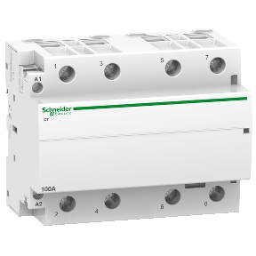

Figure 14 Schneider Electric A9C20884 ICT 100A 4NO 220...240V 50Hz contactor [15]

Another important device is the grounding control relay. The integration of over voltages that exceed the rating of the equipment connected to the power system with the mains ground of the micro grid prevents the interruption of the coordination of earth fault safety in the power system. And the requirement of the grounding control relay with depending on inverter grid topology, which in this case due to Sinexcel inverter has three phase four wire grid connection, in the case of a line-ground fault, generally to get less severe fault currents but more severe voltage unbalance than if the neutral were present in an off-grid situation, it is needed to have ground-connected neutral wires. Figure 15 ABB ESB25-31N-01 Installation Contactor represents the grounding control relay. Which it has 24 V rated operational voltage, rated operational current 25 A, 4 pole, 3 normally open and 1 normally close contacts feature [16].

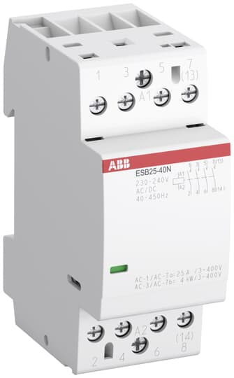

Figure 15 ABB ESB25-31N-01 Installation Contactor [16]

Under the consideration of operating voltage of used devices required 24 V power supply, and in this project used one is shown below in Figure 16 Siemens LOGO!POWER 24 V / 1.3 A Stabilized power supply input [17], in case of battery shutdown situation if it is not possible to use battery 24 V output voltage. For better understanding FEMS operation in battery off situation can be considered. While supply input of power supply input 100-240 V AC, output is DC 24 V / 1.3 A [17].

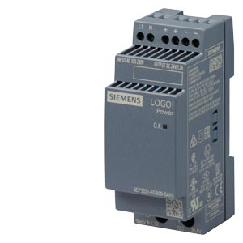

Figure 16 Siemens LOGO!POWER 24 V / 1.3 A Stabilized power supply input [17]

After the main control relay before the load connection to assure protection to people and installation against current to earth residual current circuit breaker used with two miniature circuit breakers. Earth residual current circuit breaker shown in Figure 17 ABB F204 A-63/0,3 Residual Current Circuit Breaker [18]. They have two different tripping mechanisms, the delayed thermal tripping mechanism for overload protection and the electromechanics tripping mechanism for short circuit protection [19].

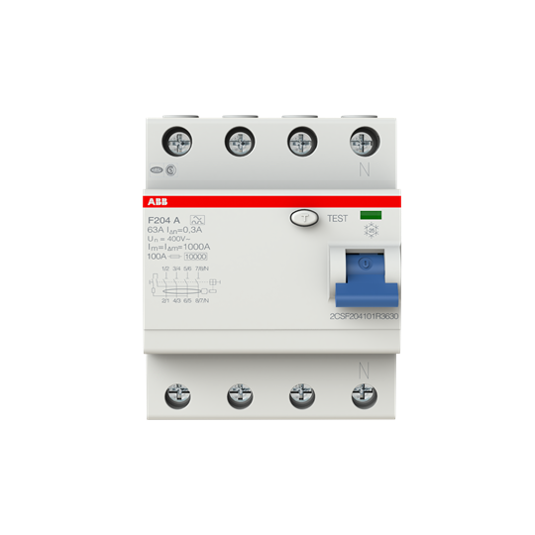

Figure 17 ABB F204 A-63/0,3 Residual Current Circuit Breaker [18]

Another miniature circuit breaker was used to operate an intentional grid islanding and simulate grid failure, as shown in Figure 18 ABB S203-B10 Miniature Circuit Breaker - S200 - 3P - B - 10 ampere [20].

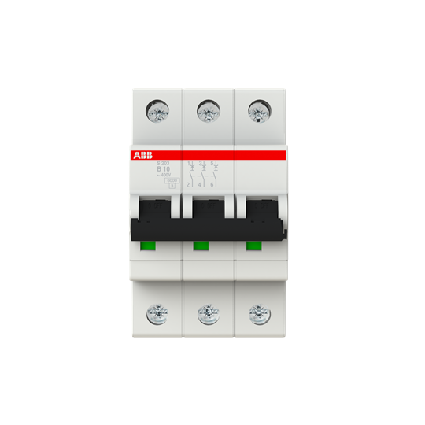

Figure 18 ABB S203-B10 Miniature Circuit Breaker - S200 - 3P - B - 10 ampere [20]

Similar to S203-B10 with higher ampere rate Miniature Circuit Breaker - S200 - 3P - C - 63 ampere used in order to create switch control for emergency loads which stands between loads and main relay. The devices used were implemented prior to the development of the circuit diagram, and the power and communication connections of the devices are discussed in the following section.

Furthermore, rather than combining these devices and creating a new circuit, a compact automatic transfer switch designed by combining under voltage detection, main switch, and timer devices could be used. As an example, a suitable automatic transfer switch for this project could be the ABB system labelled OTM63F4CMA24D, which has a rated operational current of 63A and an operational voltage of 24V [21]. Furthermore, ABB's OTM63F4CMA24D system can provide a seamless transition between public and microgrid. And with this system, much of the complicated wiring is avoided, as is the Wago fieldbus coupler device used to monitor each relay and obtain status information, as well as the simple-to-switch devices used for modbus communication.

In addition to these advantages, OMD automatic control units that will provide communication between OTM63F4CMA24D and FEMS via modbus should be used. OMD automatic control units can be used with OTM63F4CMA24D motorized change-over switches in order to assemble an automatic transfer switch [22]. And, when the prices of these devices are considered, it is three times the price of the circuit produced and the same price as the inverter used, and the automatic transfer switch is suitable for use in larger-capacity, industrial-sized applications rather than low-capacity applications.

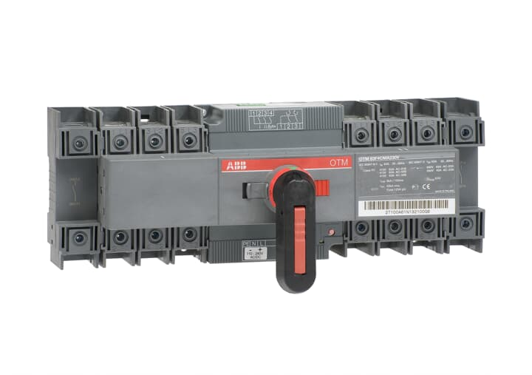

Figure 19 ABB's OTM63F4CMA24D automatic transfer switch

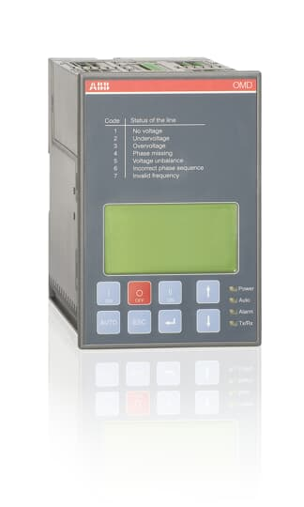

Figure 20 ABB's OMD800E480C-A1 automatic control unit

## Circuit design

The design of circuit diagrams of the power and communication connections of the devices is explained step by step in this section after being illustrated with a simple diagram. In a clear sentence, the circuit diagram that will include the transition from public grid to micro grid for this project is given in Figure 19 Simple circuit design illustration. The red line represents the network's ground link and is seen on the inverter, as well as how the neutral connection is made with the green line on the grounding relay in the off-grid state, where the system with under voltage detection is located, and where the loads are linked based on load size. Furthermore, the key relay is between the network and the inverter, and a simple expression shows how these devices are linked to the Wago fieldbus coupler system with yellow communication connection.

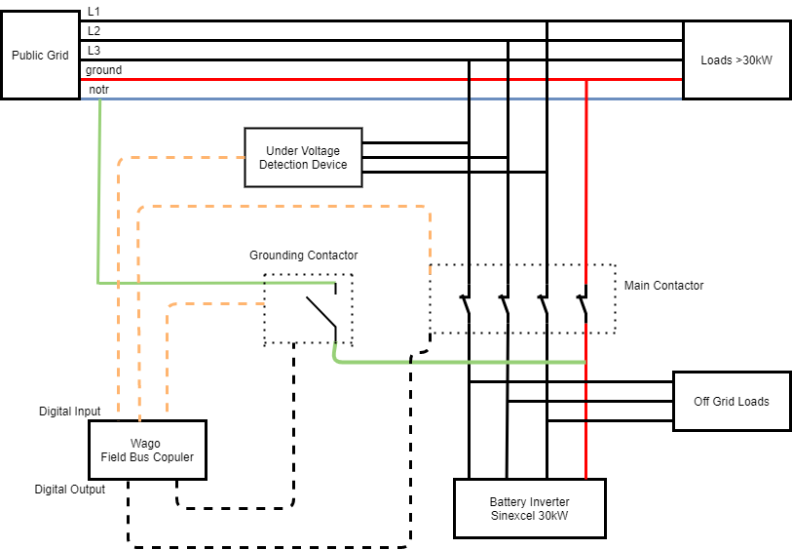

Figure 21 Simple circuit design illustration

Circuit design starts with creating terminals for costumer and provides power connection points for inverter, emergency power supply loads and in this case due to the fact that Sinexcel battery inverter allowed charge-discharge power 30kW, loads will be connected to emergency power supply loads terminal can have maximum 30kW consumption. Terminal which is indicated by X1 is public grid connection point and terminal connections can be seen in Figure 22 Terminals for costumer (bottom row). Grid connections created as shown two port for each phase like X1.L1.1, X1.L1.2 X1.L2.1, X1.L2.2, X1.L3.1, X1.L3.2,X1.N.1, X1.N.2 so that connection can be made to under voltage detection device and main relay.

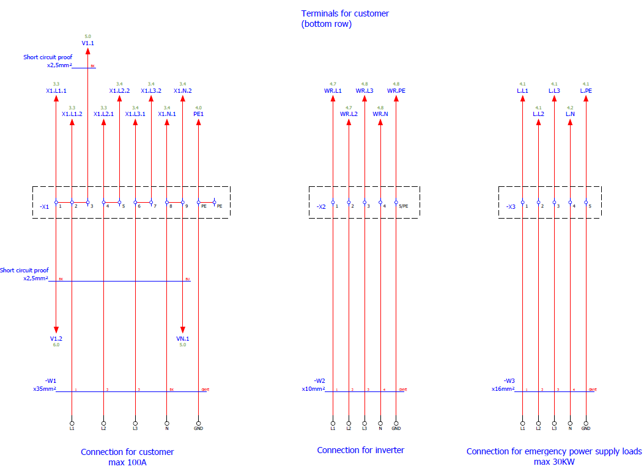

Figure 22 Terminals for costumer (bottom row)

Under voltage detection device and main relay connection can be seen in Figure 23 Under voltage detection and main relay. The device which is shown by K2 label is under voltage detection device and Q1 represents the main relay. F5 is the ABB S203-B10 Miniature Circuit Breaker - S200 - 3P - B - 10 ampere. Which is also used to simulate the off-grid condition by disconnecting the public grid connection from the under-voltage detection device and main relay.

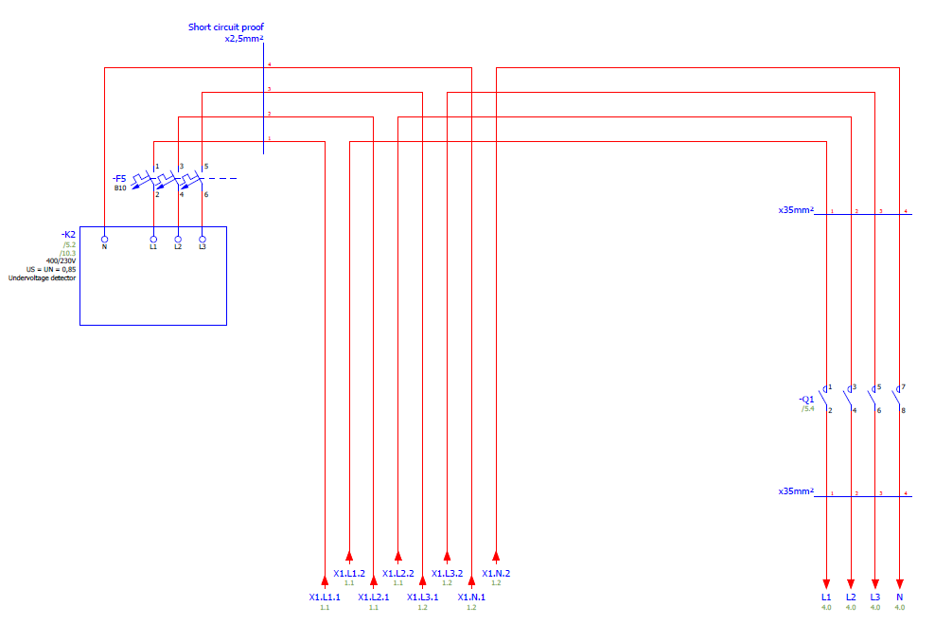

Figure 23 Under voltage detection and main relay

Output of the main relay before goes to provide power for emergency loads goes to F6 which is miniature circuit breaker - S200 - 3P - C - 63 ampere. Start point for emergency power done via grounding relay represented via Q2 and Q10 represents inverter line connections shown below in Figure 24 Start point for emergency power.

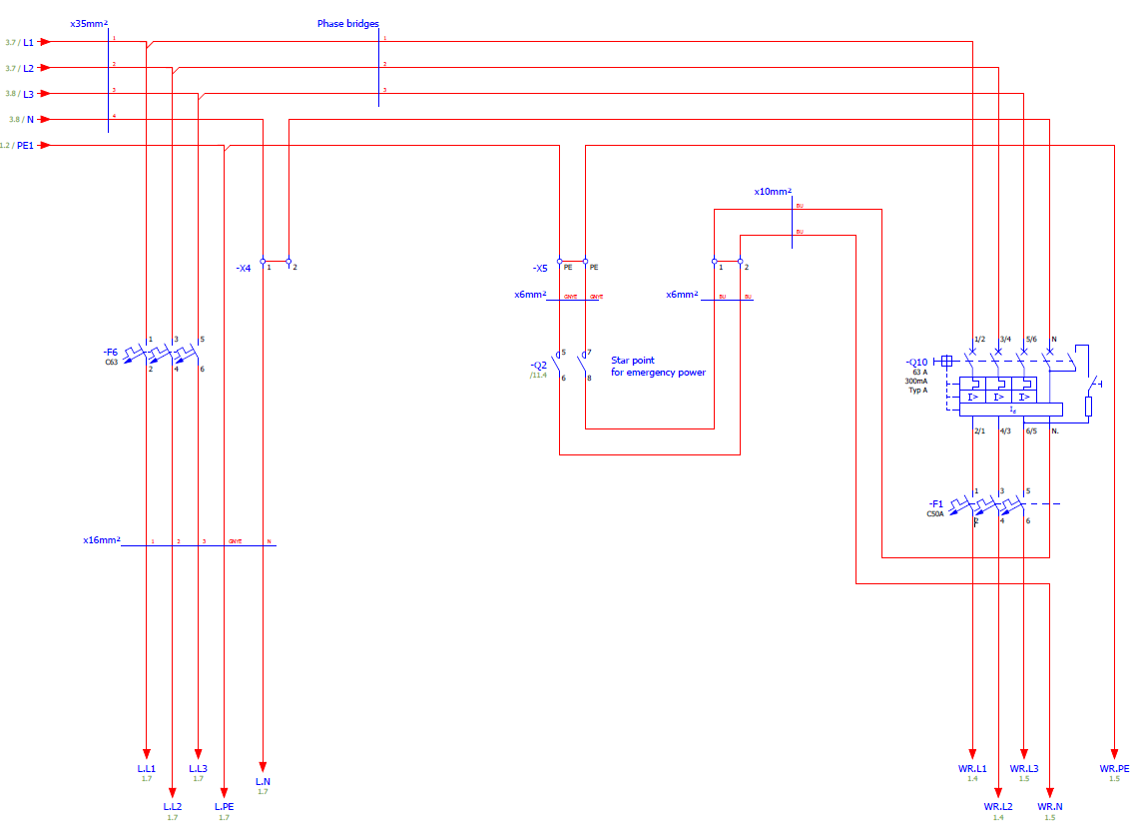

Figure 24 Start point for emergency power.

In the event of a power outage, the power to devices such as FEMS, grounding relays, timers, and Wago fieldbus coupler that are powered by the 24-volt power supply will be cut off, so power is also supplied by the battery to prevent this scenario. Power supply and battery power connection diagram shown in Figure 25 24V power supply and battery 24V connection.

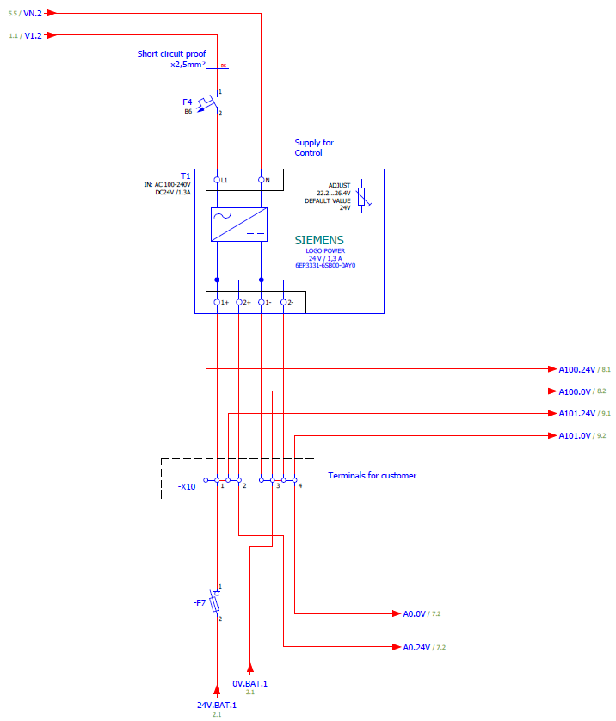

Figure 25 24V power supply and battery 24V connection

And DC supply control shown in Figure 26 DC supply control.

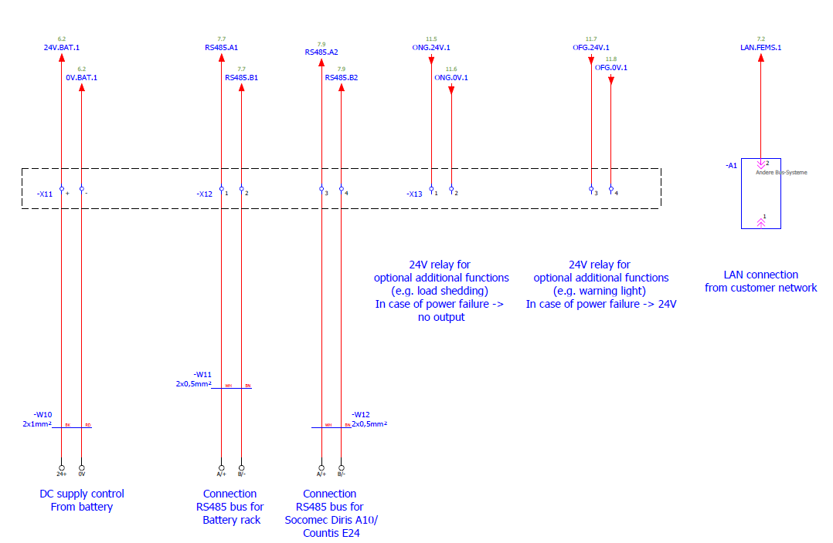

Figure 26 DC supply control

Figure 27 Device communication connections shows the communication connections between grounding relay, main relay, timer and under voltage detection device. As it mentioned before Q1 stands for main relay, Q2 for grounding relay, K2 under voltage detection, as a new label K1 represents the protection fuse for 24 V power, and K3 will be the adjustable timer. Required logic and control algorithm to operate based on availability of grid connection status will be discussed in 3.6.3 Software implementation.

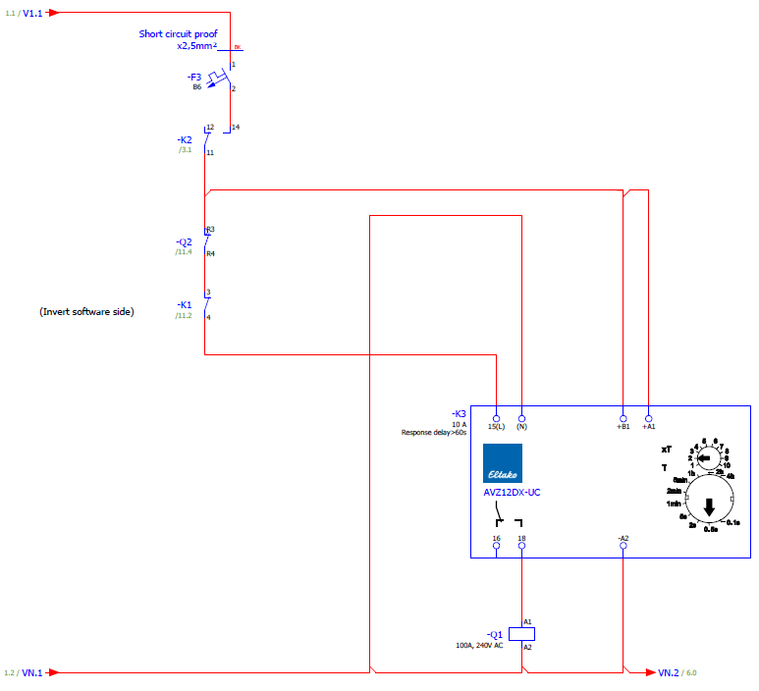

Figure 27 Device communication connections

Figure 28 FEMS communication depicts the Modbus communication link and power connection of the FEMS. There are used two easy sync adapters, one of them used in between battery and FEMS communication and the other one connected to use in case of having a grid meter.

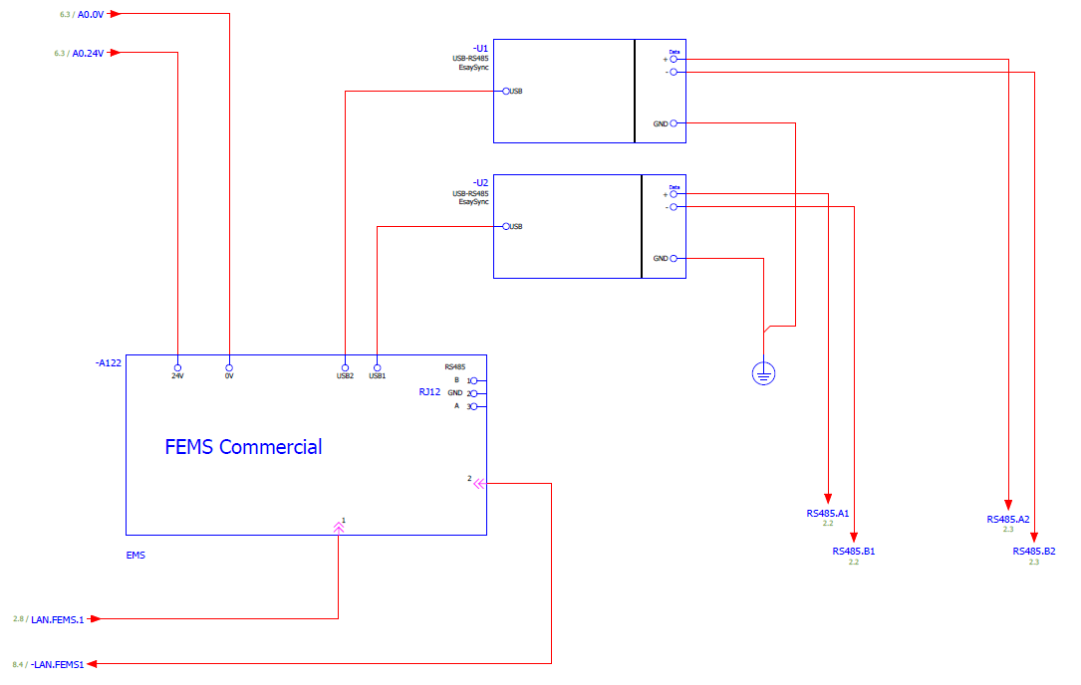

Figure 28 FEMS communication

Communication between Wago fieldbus coupler and switching relays and under voltage detection depicted below in . Current relay status will be read via Wago input channels and each channel will be mapped to specific channel. In this project main relay input channel will be “DigitalInputM1C1”, grid connection status detection “DigitalInputM1C2” and grounding relay will be “DigitalInputM1C3”.

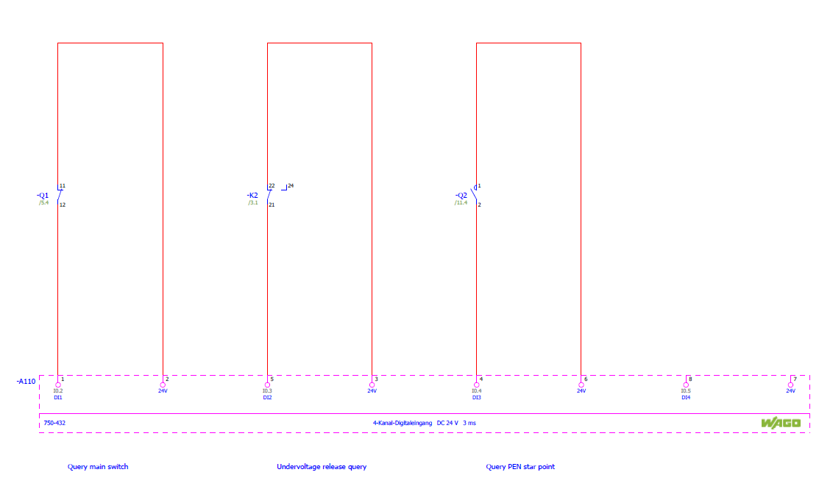

Figure 29 Wago fieldbus input channels

And relay position according to the grid availability will be controlled via Wago fieldbus coupler output channels which in this case main relay output channel will be “DigitalOutputM1C1”, to avoid confusion between input and output channels relation specially for grounding relay output channel connected to second channel of second module of Wago fieldbus coupler which makes the channel as “DigitalOutputM1C2”. Figure 30 Wago fieldbus output channels depicts the main relay and grounding output channel connection.

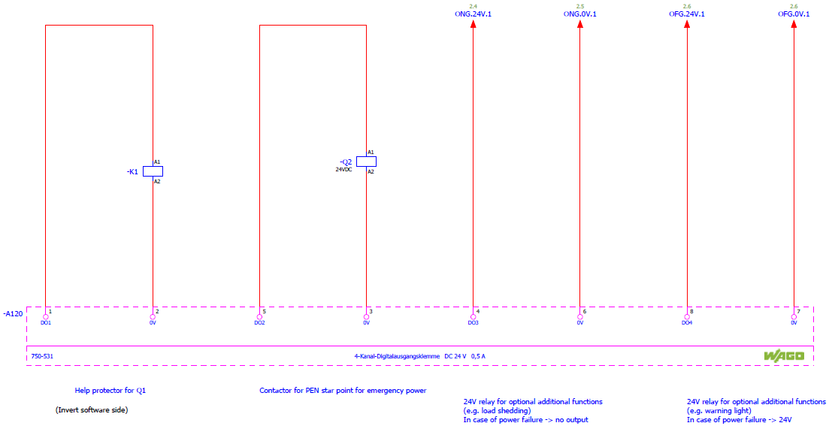

Figure 30 Wago fieldbus output channels

## Software implementation

In this project, a modular platform for energy management applications, an Open-Source Energy Management System (OpenEMS), which was developed to meet the requirements of monitoring, controlling, and integrating energy storage with renewable energy sources, was used [23]. OpenEMS is used in commercial products with a high level of reliability as well as scientific research projects. Main strengths of OpenEMS are, it is modular framework and flexibility to integrate with hardware from different vendors, subsystem software versions and Battery Management Systems (BMS) via a well-established abstraction model of digital twins.

As will be explained in the following sections and as it can be seen in Figure 32 OpenEMS Edge Architecture [24], the existing OpenEMS architecture includes natures such as converter, energy storage system, meter, battery. For any inverter with off-grid feature to be used in this project, the OpenEMS component Generic Energy Storage System, which is created with the combination of inverter and battery and is designed for integrated inverters to operate only if there is a public grid, will be expanded to Generic Off-Grid Energy Management System extending with Abstract Generic Off-Grid ESS, and implementing with ESS Off-Grid nature which is also extended from Managed Symmetric ESS nature. Generic Off-Grid ESS consist of “Io Off-Grid Switch” component implements “Off-Grid Switch” nature, “Sinexcel Battery Inverter” component which is extended via “Off-Grid Battery Inverter” nature also extended from “Battery Inverter” nature and the third component is “Soltaro Battery” extended from “Battery” nature. While the "Io Off-Grid Switch" component will be responsible for providing the current control relay status and controlling them in order to bring the control relay in a required position according to grid connection control mechanism. The "Off-Grid ESS" will be a nature for Generic Off-Grid ESS and “Off-Grid Battery Inverter” will be common nature and responsible for all off-grid able battery inverters. After giving the terminology and architecture of OpenEMS, off-grid natures and their channels which will be developed for the generic off-grid energy storage system will be explained in detail under 3.6.3 Software implementation.

### Software architecture

The basic structure of the FENECON energy management system (FEMS) can be reduced to three components, the edge, the backend, and the UI. The FEMS Edge is the component that is responsible for real-time control and communication with connected devices, including the energy storage system. It is installed directly by the end user on a Raspberry Pi or comparable hardware. The edge component acts as a communicative interface between the backend connected via the Internet and the system components on site. These mainly consist of the battery inverter and the battery.

The backend is the backbone of the energy management system installed on a cloud server. The relevant customer data is processed here and stored in an influx database. It also provides the interface between the UI and the Edge. The user interface (UI) is the communication interface between the system and people. Most of the possible interactions and data are exchanged via online monitoring as shown in Figure 31 OpenEMS System Architecture [23]:

* OpenEMS Edge runs on site, communicates with devices, and services, collects data, and executes control algorithms [23].
* *OpenEMS Backend* runs on a (cloud) server, connects the decentralized Edge systems, and provides aggregation, monitoring, and control via the internet [23].
* *OpenEMS UI* provides a real-time user interface for web browsers and smartphones [23].

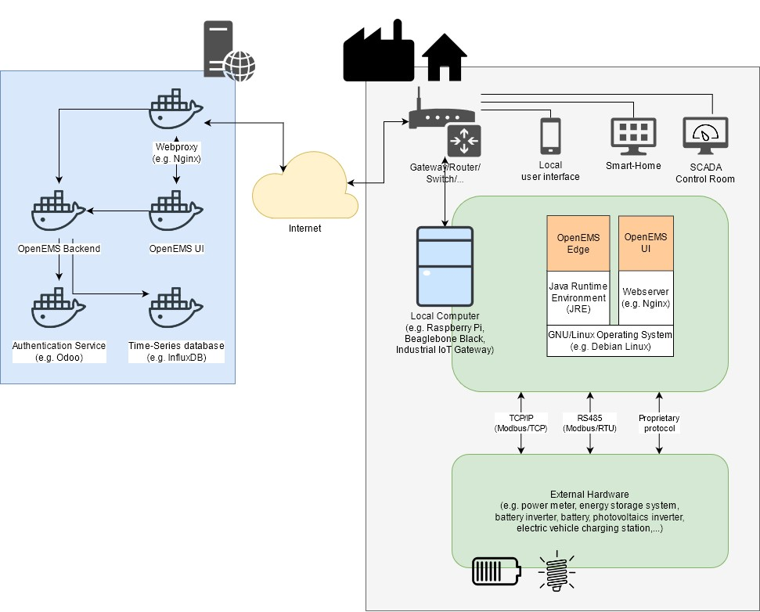

Figure 31 OpenEMS System Architecture [23]

In comparison to other energy management systems, FEMS has various levels of abstraction, which means that it can serve as a largely manufacturer-independent communication interface. Thanks to state-of-the-art support for connectivity due to communication errors, data loss problems and data updates taken care of by FEMS, there is no need for the consumer to consider this kind of issue. In addition, the cluster mechanism allows for communication with the devices used at the same time. In this project software implementation mainly will be done in OpenEMS Edge and it enables local control of external hardware, independent of the internet connection. It also facilitates rapid data analysis, fast response times and reduced network traffic. OpenEMS Edge is implemented in the Java programming language and requires a Java Runtime Environment (JRE) [23]. This allows convenient development on a personal laptop on any operating system. Furthermore, for productive use, the software typically runs on an Industrial IoT Gateway or in a development board like a “Compulab” [25] which presented in chapter 3.3 with GNU/Linux Operating System.

### Terminology

This section describes some of the core concepts and terms commonly used in OpenEMS Edge.

#### OpenEMS Component

A component is the fundamental building block in OpenEMS. A Component Description that is parameterized with component properties and used to track the component dependencies and manages the Component Instance [26]. Within the used OSGi which is a Java framework for developing and deploying modular software programs and libraries [27], Java framework, an OpenEMS component represents a service with requirements and capabilities. OSGi provides the capability to enable, modify or disable an OpenEMS Component at any time.

Each configured and activated OpenEMS component will have its own unique id component. For example, the configured first inverter is "ess0" and the "ESS Symmetric Fix Active Power" controller is "ctrlEssSymmetricFixActivePower0" to be used when the id component "ess0" is loaded or discharged, which should be specified in the controller. A further illustration which it will be explained in detail in 3.6.2.7 Apache Felix Web Console in order to configure the settings of FEMS can be represented as follows:

The first battery programmed "battery0" to be used with the inverter that is connected must be configured in the "ess0" configuration as well as “battery0”, first battery inverter programmed will be “bateryInverter0” and first off grid switch component will be “IoOffGridSwitch0” which has to be configured in “ess0”. “ess0” will be a generic off grid Ess component. And Wago fieldbus coupler will have “io0” unique component Id. As a result, unique component IDs also enable each component to be defined and differentiated. Each OpenEMS component has a defined set of data points. These data points are called “Channels”. Each represents a single piece of information about a component. By definition, each channel has a unique ID, the “Channel-ID”, within its parent component. For an instance, to be able switch on/off main control relay, input values which is configured in off grid switch component will be read as io0/DigitalInputM1C1 and output control signals will be handled via io0/DigitalOutputM1C1 another example, battery voltage will be mapped to the “battery0/Voltage” channel.

Channels are defined by metadata like descriptive text, including access-mode (“read-only”, “read-write”, “write-only”), data type (“string”, “integer”, “float”, etc.), and unit of measure (“Watt”, “Volt”, “Degree Celsius”, etc.). It is up to the OpenEMS component to provide the input for its read-channels as well as triggering actions on write-channels.

The OpenEMS uses a channel instead of a variable. They have significant advantages over variables, as they can, for example, store an integer number with the associated information. In addition, each channel has a unique ID that is later used by the backend. The channels can save information with their metadata. When implementing the inverter, the channels are used to store information from the Modbus register. Each writable and readable inverter register has its own storing data channel. According to the implementation table provided by Sinexcel, where all the registers are specified, the channels are given the names chosen in the register table. This will encourage potential troubleshooting. The specific channels of the Sinexcel inverter are specified in the "Sinexcel “. It should be noted that there are various types of channels available. For implementation, channels are needed for writing integer numbers (IntegerWriteChannel), reading integer numbers (IntegerReadChannel), reading strings (StringReadChannel) and reading pieces (StateChannel). In addition to the channels of the Sinexcel inverter, the general channels that each inverter should have are specified. In addition to the Sinexcel inverter channels, general channels are specified that each inverter should have in OpenEMS. These are required to ensure that all controllers, such as compliance with the charging level set, operate. This implies that the right Sinexcel unit is allocated at the same time when a number is saved.

#### Nature

Certain categories of devices and services provide the same kind of information (i.e., channels) [23]. To group these similar devices and services, OpenEMS defines “Natures” as sets of characteristics and attributes which need to be provided by each component that implements them. That is, a Nature extends a normal Java interface with channels. The hardware component is referred to as a "device" in the software structure and represents the lowest level of communication. At present, the "device" still has a brand name and a model name. At the next level, this hardware-specific information is suppressed, and the device is abstracted from its "nature." Possible manufacturer-independent modules that always provide and require similar communication data are defined as "Nature." For example, a "nature" can be an ESS (Energy Storage System) or a meter (measuring device). To communicate with the nature, the channels are used, which are always linked to nature and which transport the communication data. For example, the Nature Meter channel is called "Active Power" which describes the power of the measuring device that has just been measured. The channels can now be used to communicate with the actual logic of the energy management program, the scheduler. This is responsible for the configuration of the controllers/applications, which can be arranged by different schedulers according to different aspects. For example, this works by charging the battery, time, or manual input status. In the end, the controllers define the operating mode of the energy system, which is analogous to the smartphone application.

#### Architecture

The OpenEMS Edge software architecture is carefully designed to abstract device communication and control algorithms in a way to provide maximum flexibility, predictability, and stability while simplifying the process of implementing new components. The scheme depicted in Figure 32 OpenEMS Edge Architecture [24] shows the abstraction of hardware via Channels, Natures and Devices as well as the execution of control algorithms via Scheduler and Controllers.

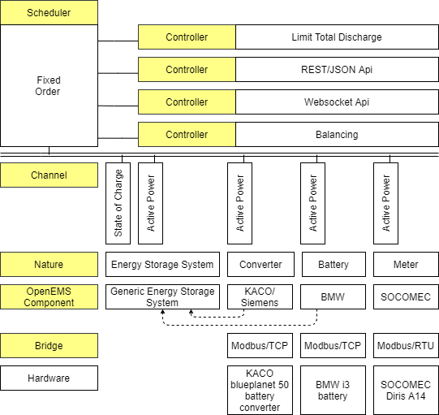

Figure 32 OpenEMS Edge Architecture [24]

#### Controller

Since firmware does not offer any function, software packages are still required to define how the energy storage system works. These packages are called "controllers". The terms "applications" or "apps" are also used in order to create a more end-user-friendly presentation. In other words, controllers are consumers of Channel. Examples for controllers are:

* “Controller.Backend.Api” connects to the OpenEMS Backend server [23]
* “Controller.Debug.Log” Constantly shows the most important values of all Components on the console. This is often activated by default to be able to track the running system easily [23].
* “Controller.Ess.Fix.Active.Power”: Sets a fixed active power for charging/discharging of a symmetric energy storage system [23].

Controllers are executed regularly e.g., once per second (see “Cycle” below”). The scheduler mechanism sets the priority in which the controllers are executed [23].

#### Scheduler

Typically, more than one controller is active in OpenEMS Edge simultaneously, which makes it necessary to prioritise their execution.

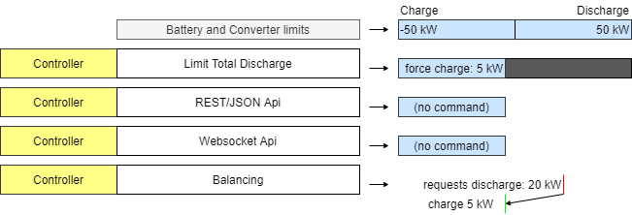

Figure 33 Prioritisation of BESS power setpoints

Figure 33 Prioritisation of BESS power setpoints shows, how the interval of possible solutions is reduced by sequentially executed controllers. In the example the initial BESS limits from battery and converter allow charging and discharging with 50 kW. The “Limit Total Discharge” controller then adds a constraint to force charge the BESS, i.e., enforcing a setpoint that is smaller than -5 kW. No further limitations are applied by the Api controllers. The Balancing controller then requests discharging the BESS with 20 kW but is forced to fulfil the constraints. Eventually the BESS gets force-charged with 5 kW. The scheduler in OpenEMS Edge handles this prioritization and sequential execution of controllers. In the example of controlling a BESS, a separate “Ess.Power” component synchronizes with the IPO cycle and manages feasible solutions via a linear equation system that allows constraints on three-phase or single-phase setpoints for active and reactive power. It is also used for optimizing distribution of setpoints in the case of multiple BESS.

#### Online Monitoring

To allow easy access to device data, there is an internet-based "monitoring" on which FEMS data is displayed in an end-user-friendly manner. Data entry for manual supervision, which is possible for some applications, is also carried out through online monitoring. The start page of the online monitoring shows the real-time status of the system and is shown in Figure 34 OpenEMS UI Live view.

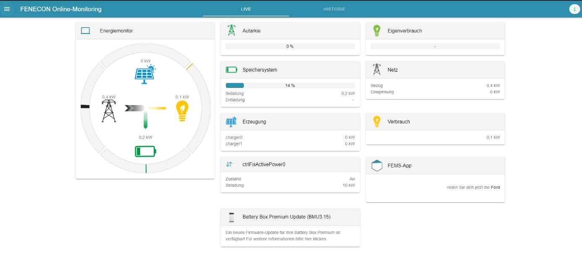

Figure 34 OpenEMS UI Live view

On the left is a flow diagram of current energy flows between the four components of the electricity grid, production, consumption, and energy storage. On the right, more accurate data on the individual components can be called up. In order to achieve the greatest possible modularity in the display, all aspects are displayed as individual widgets. This means that online tracking can be extended to include new applications, for example, at any time and without significant development work. The collected measurement data can be visualized interactively in the "History" shown in Figure 35 Online-Monitoring live mode , below.

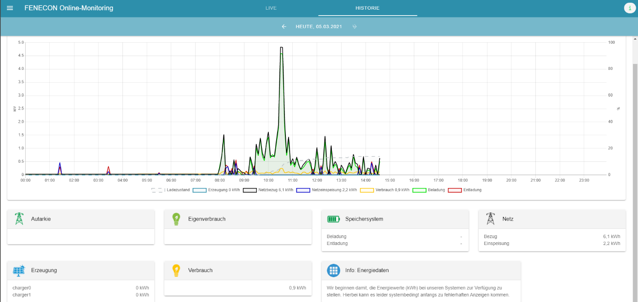

Figure 35 Online-Monitoring live mode view

Both the observation time and the graphics to be shown can be changed in the diagram. OpenEMS UI also provides a way to instantiate an OpenEMS Component from a factory by providing configuration parameters. The “Settings | Install Components” view shown in Figure 36 OpenEMS UI List of factories from EdgeConfig and generates dynamic configuration forms per factory (Figure 37 OpenEMS UI Setup battery component).

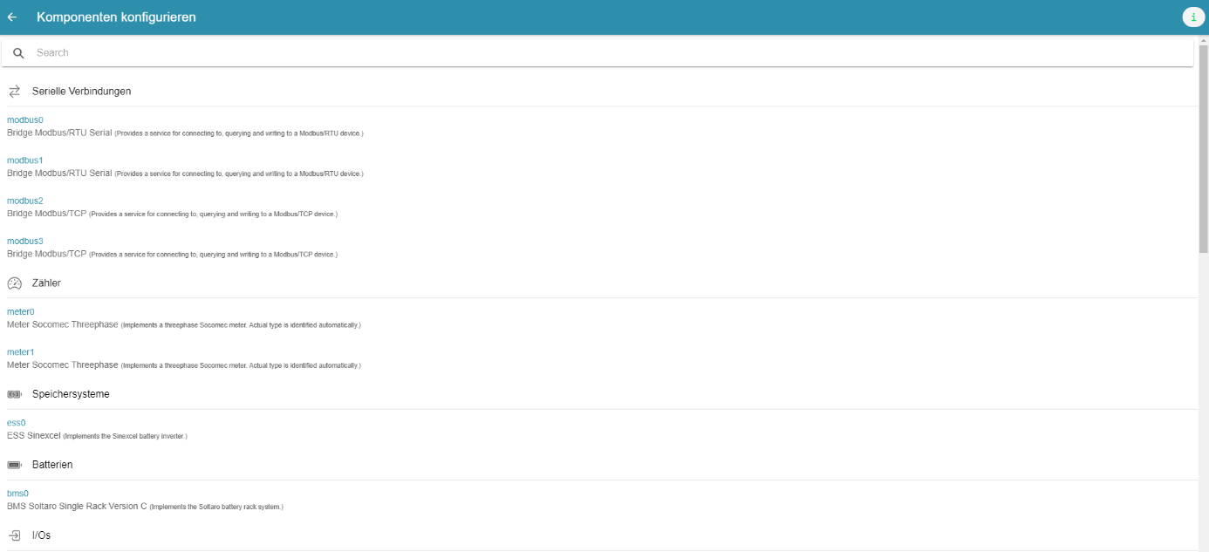

Figure 36 OpenEMS UI List of factories

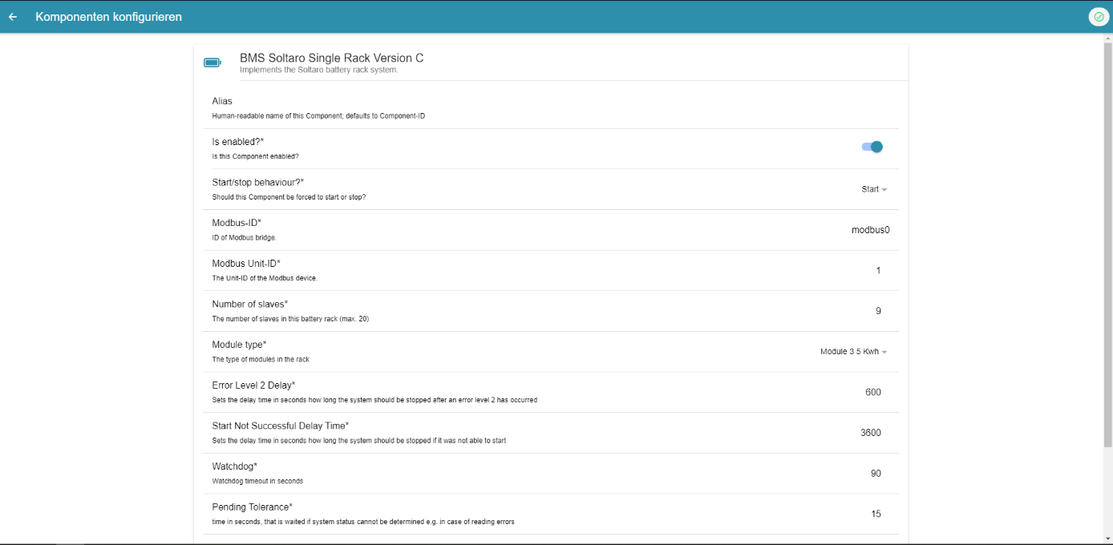

Figure 37 OpenEMS UI Setup battery component

Detailed UI configuration of this project will be given in chapter 3.6.4.3 Configuration for the OpenEMS backend and OpenEMS UI

#### Apache Felix Web Console

The Java/OSGi framework provides the Apache Felix Web Console as a standard tool to adjust the configuration of any OSGi based software like OpenEMS Edge internally uses a similar approach to the EdgeConfig, without OpenEMS specific extensions like channels information.

fems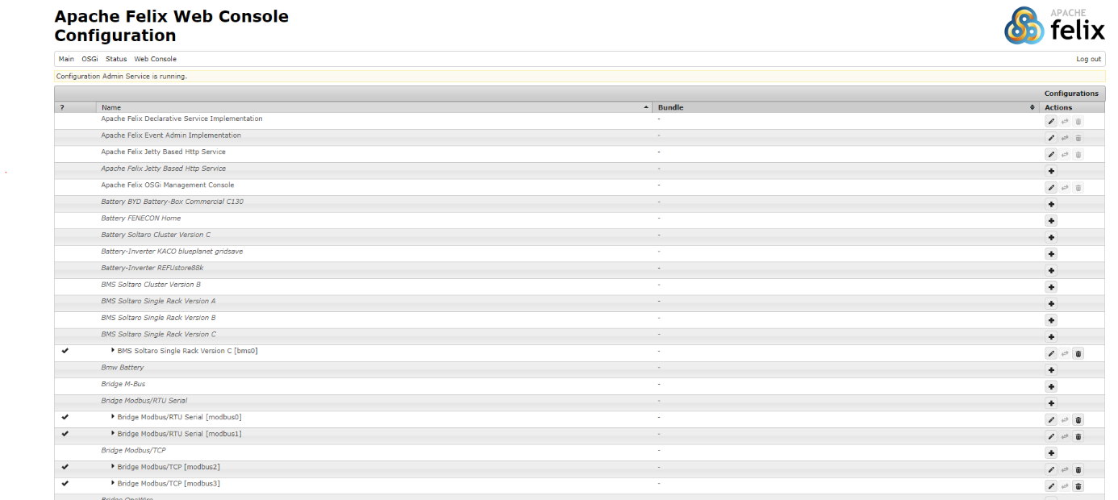

Figure 38 Apache Felix Web Console

### Software implementation

In chapter 3.6.2.2 Nature, description of nature has been given, and it is noted that similar devices and services are grouped together from the same type of information. In this project, the Generic Off-Grid ESS nature will be generated to collect inverters designed to work in off-grid mode within the same group. The architecture shown in Figure 32 OpenEMS Edge Architecture [24] has been expanded with the Generic Off-Grid ESS in the form of the following Figure 39 OpenEMS Edge architecture for Generic Off-Grid ESS.

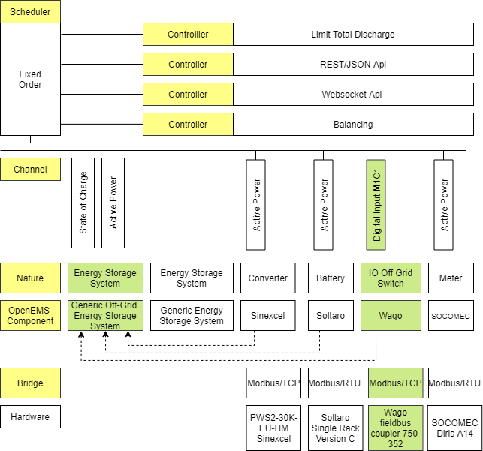

Figure 39 OpenEMS Edge architecture for Generic Off-Grid ESS

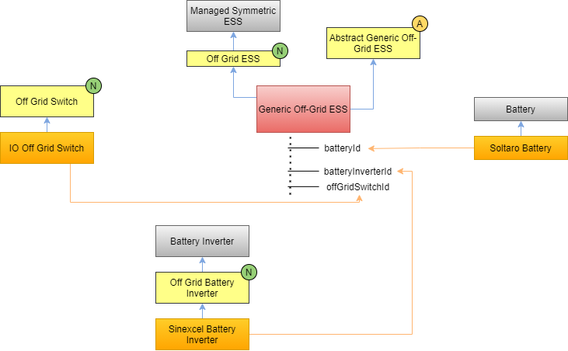

Figure 40 Created and used natures with components in Generic Off-Grid ESS

Before we go through how Generic Off-Grid ESS regulates the devices in the state machine, we will go through Sinexcel battery inverter implementation and its extended nature,

1. “Off-Grid Battery Inverter”,
2. “Off-Grid ESS” component,
3. “Abstract Off-Grid ESS” abstract class,
4. “Off-Grid Switch” nature, and
5. “Io Off-Grid Switch” components

with their channels and methods will be introduced. In Figure 38 Created and used natures with components in Generic Off-Grid ESS introduced, ***N*** letter with marked green colour represents for created natures, ***A*** stands for abstract class. There are three orange-coloured components required to build Generic Off-Grid ESS component. In addition, grey-coloured natures had been already created. To be able to recognise a battery inverter that can run off-grid, it must have common channels such as

1. off-grid inverter frequency,
2. on grid command,
3. off grid command,
4. mode on-off command,
5. inverter state, and
6. intern dc relay.

The power output of the AC sources in the stand-alone grid is limited to the stand-alone grid frequency. In case of excess energy, the load control device raises the frequency of the power supply. In the event of a grid failure, the inverter should be switched to off grid command mode and used as a generator. This is why off-grid inverter frequency and mod on-off command exist and needed. To define inverter operating state whether it is in on-grid or off-grid, on-off grid commands are defined. Figure 41 Off-Grid Battery Inverter Nature Channels introduce channels based on read type, access mode, and unit type.

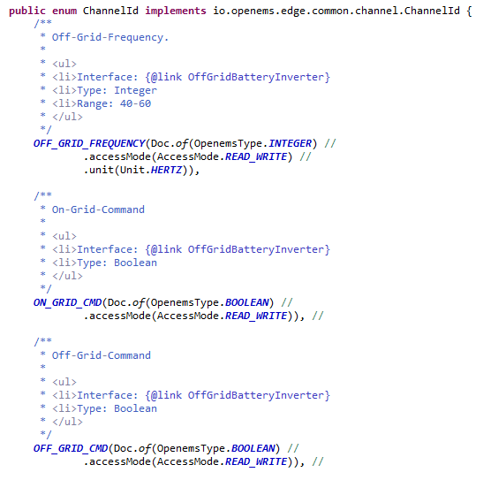

Figure 41 Off-Grid Battery Inverter Nature Channels

Getting and setting methods are shown in Figure 44 Get and set methods for off-grid battery inverter For a better understanding, “getOffGridFrequencyChannel()” returns an IntegerReadChannel which is mapped and shown in Figure 45 Off-grid frequency channel mapping in Sinexcel battery inverter implementation. FC3ReadRegisterTask will create a Modbus read task with register number 0x008A, read priority low, read type SignedWordElement and with scale factor which is defined in Sinexcel inverter Modbus protocol minus 1 which represents read value from register hast to be divided by 10. Likewise, for set value. To be able to create an abstract class which handles all control logic and switching mechanism, in off-grid battery inverter defined channels have to be mapped in battery inverter Modbus protocol. This approach has to also applied once another inverter used, so that inverter starting, stopping, setting the grid mode and off-grid frequency can be handled in Generic Off-Grid ESS component. “FC6WriteRegisterTask” creates a Modbus write task with always high priority, and necessary register number which is defined in Sinexcel battery inverter Modbus protocol. Due to fact that channel definition made in Off-Grid Battery Inverter nature, channel called via OffGridBatteryInverter.ChannelId.MOD_ON_CMD, otherwise, channels like "Active Power" that channel definition is made in Sinexcel are called in Sinexcel.ChannelId.ACTIVE_POWER format. With “get Off Grid Frequency” method, read task created and return read integer value. In order to set the off-grid frequency before starting the battery in off-grid mode, “set Off Grid Frequency” method used which is also calls already mapped “off-grid-frequency” channel but with “IntegerWriteChannel” return type. Method can be seen below in Figure 44 Get and set methods for off-grid battery inverter nature. The off-grid frequency approach demonstrated here can be extended to the rest of the channels as well.

The previously implemented "Sinexcel Battery Inverter" has been built with implementing, after developing the nature of the "Off-Grid Battery Inverter", to use off-grid features. And in Figure 42 Sinexcel battery inverter implements shows how the class declaration made.



Figure 42 Sinexcel battery inverter implements Off Grid Battery Inverter.

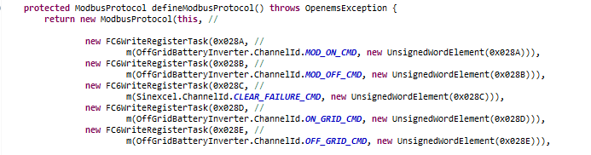

Figure 43 Off-Grid Battery Inverter channel mapping in Modbus protocol

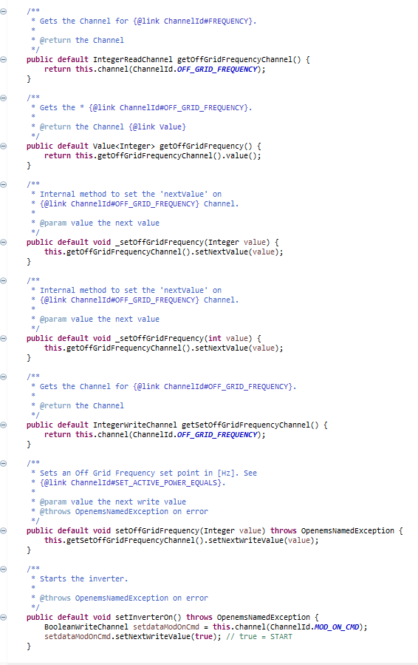

Figure 44 Get and set methods for off-grid battery inverter nature.



Figure 45 Off-grid frequency channel mapping in Sinexcel battery inverter implementation

The inverter will be operated by the Generic Off-Grid ESS using the state machine mechanism shown below in Figure 50 Battery and battery inverter state machine after the Sinexcel battery inverter Modbus protocol and battery limits such as minimum discharge voltage, maximum discharge current, maximum charge voltage and current have been defined.

There are three start-stop configurations for battery inverter: *auto, start, and stop*. Once the start operation mode triggered by Generic Off-Grid ESS, battery inverter starts with Undefined state. And every time independent to start-stop decision clears the failure with “set Clear Failure Command” method. In addition, state decision made with whether the target is start or stop. Afterwards, if the target is start and there is not any failure, next state become “Go Running”, otherwise state goes to “Error Handling” state and waits here for 120 second and eventually goes to “Undefined” state to try to start it again. In “Go Running” state failures are checked again and if there is still no error, tries to start the Sinexcel battery inverter with closing intern dc relay, in another words tries for soft start with “soft Start“ method and, sets the inverter in on state with “set Inverter On” method. While the soft Start method is specified in the Sinexcel battery inverter context class in order to keep off-grid battery inverter nature as generic as possible, this intern DC relay thought that it is Sinexcel's unique configuration, the set Inverter on method is defined in the off-grid battery inverter nature. Soft start sets the internal DC relay and once this register is set to 1, the PCS will start the soft-start procedure, otherwise, the PCS will do nothing on the DC input every time the PCS is powered off, this register will be cleared to 0. In some particular cases, the BMS wants to re-soft Start, the EMS should actively clear this register to 0, after BMS soft-started, set it to again 1 which is done in Undefined state. When the grid fails or the public grid becomes available again, the battery inverter will be stopped via Generic Off-Grid ESS, and failure clearing will be done automatically as soon as the switching necessity occurs. Generic Off-Grid ESS state machine will be explained later in detail. Soft start method is shown below in Figure 46 Soft start method, set Inverter On method is shown in Figure 47 Set Inverter On method, and clearing failure is shown in Figure 48 Set Clear Failure Command method.



Figure 46 Soft start method

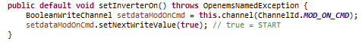

Figure 47 Set Inverter On method



Figure 48 Set Clear Failure Command method

If the “get Inverter State” method returns false, indicating that the inverter has not yet been started, the state is still Go Running; however, if the inverter is started, the next state is “Running,” and power can now be applied. Furthermore, the inverter state is often checked to see whether it is on or off, and if it is not stopped and there is no malfunction in this state, the inverter is attempted to continue. When the start-stop target turns to stop, state become first Undefined and goes to “Go Stopped” state. Here, soft Start method called to open intern DC relay and with “set Inverter Off” method stops the inverter, the method is shown in Figure 49 Set Inverter Off method. If the inverter state method returns false, the next state is “Stopped,” and the inverter stays stopped until the goal condition is restored.

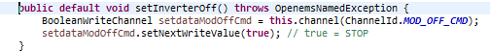

Figure 49 Set Inverter Off method

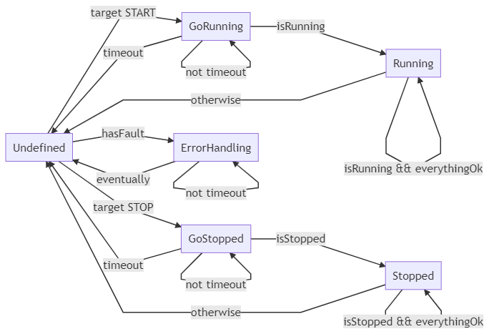

Figure 50 Battery and battery inverter state machine

In the previously implemented Soltaro battery control logic, the same state machine mechanism is used can be seen in Figure 50 Battery and battery inverter state machine. The key difference is that instead of using cleaning failure, soft start, and inverter-on methods, a pre-charging relay control method was used to prepare the battery for use or to stop, or in other words to put the battery in Running or Stopped state.

The "Io Off-Grid Switch" is another newly developed aspect that will be responsible for providing the current control relay status and controlling them in order to put the control relay into the appropriate position according to the grid connection control mechanism. The "Off Grid Switch" nature was needed to accomplish this. The design of an off-grid switch includes a *main control relay, a grounding control relay, grid status channels*, and related methods dependent on this channel. It also contains the methods “handle Writing Digital Output”, “handle Writing Digital Output for Main Contactor”, and “handle Writing Digital Output for Grounding Contactor”. Figure 51 Io Off Grid Switch Configuration shows three input channels mapped to Wago system input signals that include main, grounding contactors, and grid status states. In addition, two output channels are mapped to Wago output signals, which control the main and grounding contactors. As soon as the component is generated, the channel is initialized in the activate process. Input signal status is modified in the "handle Input" process shown in Figure 52 Io Off Grid Switch Component Handle Input method, and output channels are set in the "handle Writing Digital Output For Main Contactor", "handle Writing Digital Output For Grounding Contactor" methods separately, shown in Figure 53 Io Off Grid Switch Component Writing Digital Output for main and grounding.

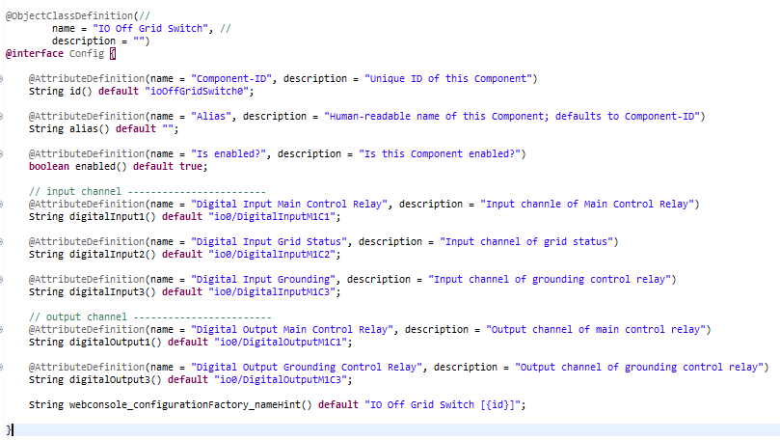

Figure 51 Io Off Grid Switch Configuration

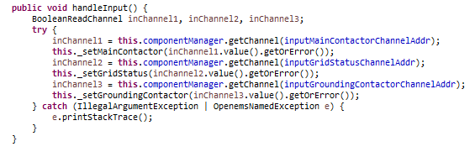

Figure 52 Io Off Grid Switch Component Handle Input method

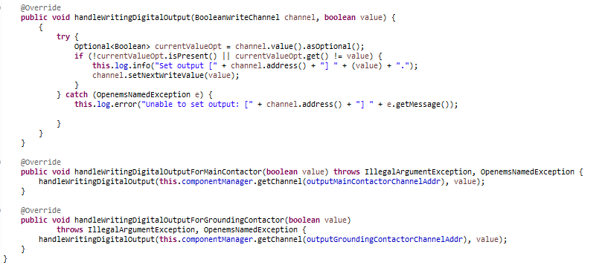

Figure 53 Io Off Grid Switch Component Writing Digital Output for main and grounding.

Regardless of the battery variability to be used in general and the model or capacity of the off-grid able inverters, the Generic Off-Grid ESS has been developed to handle with only a basic configuration, that is, to gather items with common features under a single roof, thanks to the same mechanism. The Generic Off-Grid ESS abstraction structure is defined and the functionality of the operation to be performed is introduced to the user. That way, the user is interested in what the method is doing, but not in how it does it. In this scenario, functionality comes to the fore, and how the job is done is hidden. Thus, the Generic Off-Grid ESS component will be extended via the Abstract Generic Off Grid ESS class and perform the switching process according to the start-stop choice specified in the configuration and the public grid availability with the help of created state machine which is shown below in Figure 54 Generic Off-Grid ESS state machine. Before explaining the state machine, should be mentioned that Generic Off-Grid Ess implements the ESS Off-Grid nature which is extended via Managed Symmetric ESS nature. Managed Symmetric ESS nature consist of such “Allowed Charge Power”, “Allowed Discharge Power” channels helps to define a power constraint according to the “Maximum Charge and Discharge Current”, “Maximum Charge Voltage” and “Minimum Discharge Voltage” information which is taken from the battery. Thus, ESS Off-Grid nature defined Off-Grid Ess nature was developed to create power constraints explicitly for an instance of off-grid able ESS. Provides the option, in the case of multiple parallel-connected battery inverters, to select which one should charge or discharge with the requested power for such applications. The power constraint implementation is not the concept of this study; therefore, no comprehensive details will be provided, and the implementation will be completed as a separate project.

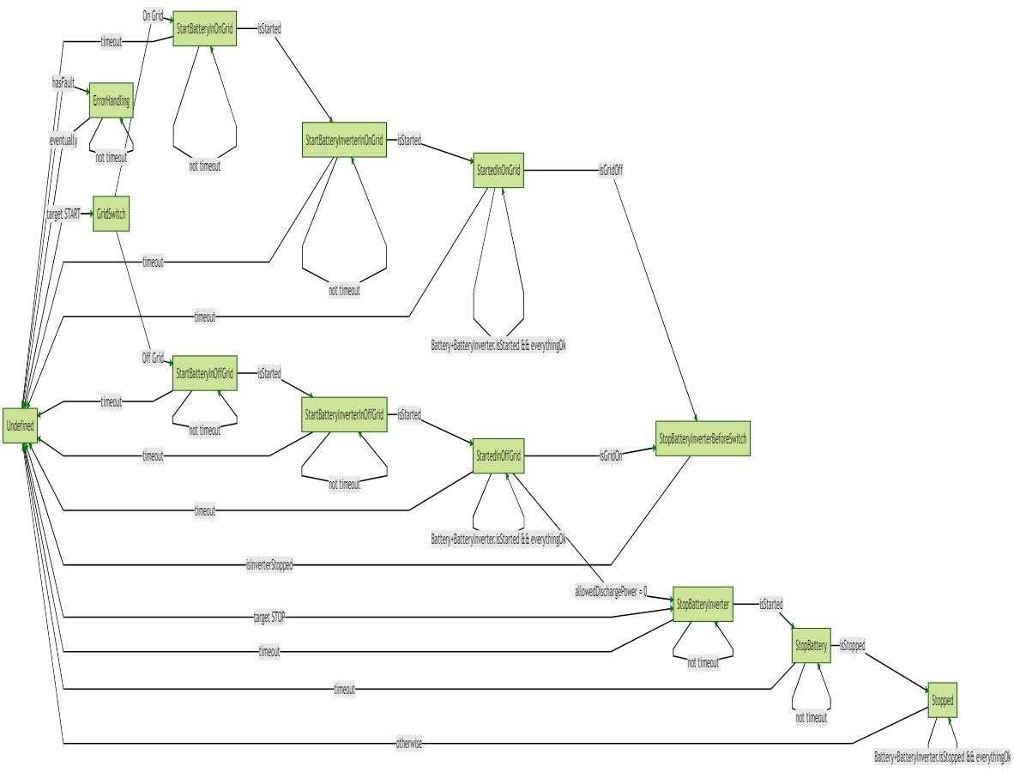

Figure 54 Generic Off-Grid ESS state machine

There are three option in start-stop configuration for Generic Off-Grid ESS: *auto, start, and stop*. Once the start operation mode triggered by Generic Off-Grid ESS, battery inverter starts with Undefined state and in this state, decision made with whether the target is start or stop. If the chosen decision made in the configuration with target stop, the battery and battery inverter stop sequence will be triggered via going to step “StopBatteryInverter” and here tries to stop battery inverter first with setting the battery inverter start-stop target to stop if maximum start time passed but attempt counter is not bigger than 30 which is in seconds hard coded static value. If the time exceeds and battery inverter not stopped, next state goes to “Undefined”, and decision will be made again. After stopping the battery inverter, battery can be also switched off with going to state “StopBattery”. The timeout application is also available in this case and for each state. After stopping battery, the battery and battery inverter stays stopped until the goal condition is restored. However, if the decision is made with target start, with going to “GridSwitch” state grid availability will be checked and required relay position will be adjusted. “GridSwitch” state decisions and relay controlling can be seen in Figure 55 Generic Off-Grid state machine GridSwitch state. In case of on-grid next state will be “StartBatteryInOnGrid” and in case of off-grid situation next state will be “StartBatteryInOffGrid”.

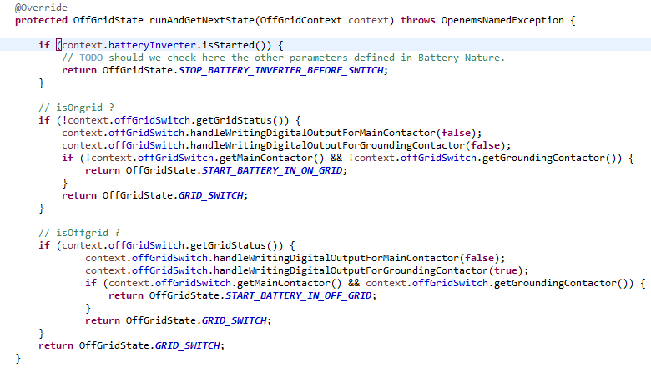

Figure 55 Generic Off-Grid state machine GridSwitch state

In the case of on-grid, the Generic Off-Grid State Machine state remains unchanged in the “StartBatteryInOnGrid” state as long as the battery state machine does not transition to the “Running” state. When the battery is switched on, the state transitions to the “StartBatteryInverterInOnGrid” state, which starts the battery inverter and sets the grid mode via the setOnGridCommand process. The Generic Off-Grid State Machine state stays in the “StartBatteryInverterInOnGrid” state as long as the battery inverter state machine does not enter the “Running” state. If the battery and inverter are started, the next condition is "StartedInOnGrid," which is shown below in Figure 56 Generic Off-Grid state machine StartedInOnGrid state and the situation will stay the same as long as there is no malfunction, the battery or inverter does not stop, and the public grid is present. However, If the battery or battery inverter fails for whatever reason, the state will be "Undefined," and if there is a power failure, the battery will first wait 3 seconds when grid mode is set to undefined, and then enter "StopBatteryInverterBeforeSwitch" to stop the battery inverter. When the battery inverter is turned off, it returns to the "Undefined" state, and the "GridSwitch" state is reached because the target start was previously set. It was stated that a stop sequence would be called if the allowed discharge power is equal to 0 for battery safety. If the battery is appropriate for operation, the status changes from "GridSwitch" to "StartBatteryInOffGrid" as a new event. This situation is identical to the "StartBatteryInOffGrid" state, but it just helps the battery to start. Since the "GridSwitch" state specifies operating mode and relay positions based on grid availability, two types of states are specified instead of a general "StartBattery" state. In other words, simply making the status "StartBattery" would trigger the work done on the "GridSwitch" to decide the next state to be replicated, or it will result in the use of only one state as another process, adding the task of starting the battery as well as the work done on the "GridSwitch". As a result, it will be difficult to differentiate between situations with different roles and will complicate analysis in undesirable situations. The next situation after battery start-up, as in the case of the On-Grid, would be inverter start-up, but the situation here varies from off-grid frequency setting and grid mode setting. As it shown below in Figure 57 Generic Off-Grid ESS state machine StartBatteryInverterInOffGrid state frequency settings done via calling “setOffGridFrequency” method and grid mode via “setOffGridCommand” method. Similarly, once the settings are completed and the battery inverter is in the "Running" mode, the next state will be "StartedInOffGrid” and the situation will stay the same as long as there is no malfunction, the battery or inverter does not stop, and the public grid is not present. However, If the battery or battery inverter fails for whatever reason, the state will be "Undefined," and if the grid is available again, the battery will first wait 65 seconds when grid mode is set to undefined, and then enter "StopBatteryInverterBeforeSwitch" to stop the battery inverter. As it mentioned in section 3.4 Evaluation of suitable switching devices, according to the technical rules published by VDE Verband der Elektrotechnik Elektronik Informationtechnik e.V. the connection of generating plants and storage to the network operator's network may only take place if it is determined by a suitable device that both the network voltage is within the tolerance range of 85% Un to 100% Un and the network frequency is within the tolerance range of 47.5 Hz to 50.1 Hz for a duration of at least 60s [13]. Although the 60 seconds wait is made with the Timer device, within the network availability, 65 seconds are waited for security purposes with the software. In addition, one of the steps forcing the stop sequence to trigger is to drop the allowed discharge power to 0. And in this case state switches from “StartedInOffGrid” to “StopBatteryInverter”.

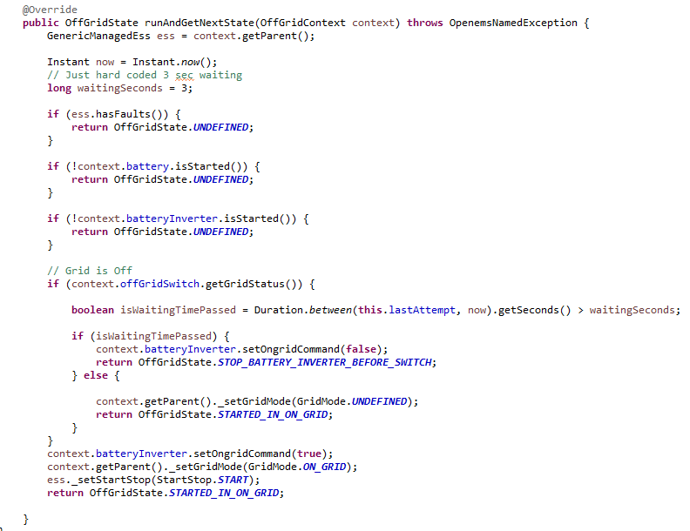

Figure 56 Generic Off-Grid state machine StartedInOnGrid state

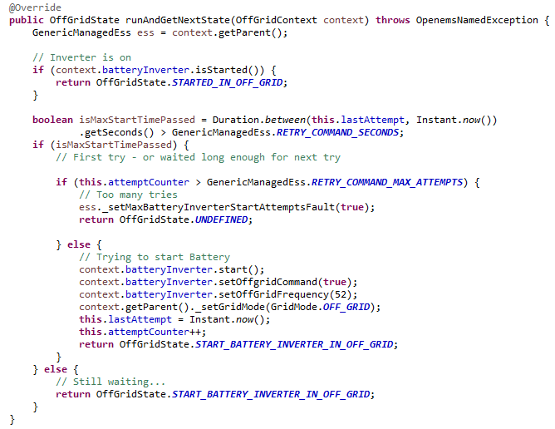

Figure 57 Generic Off-Grid ESS state machine StartBatteryInverterInOffGrid state

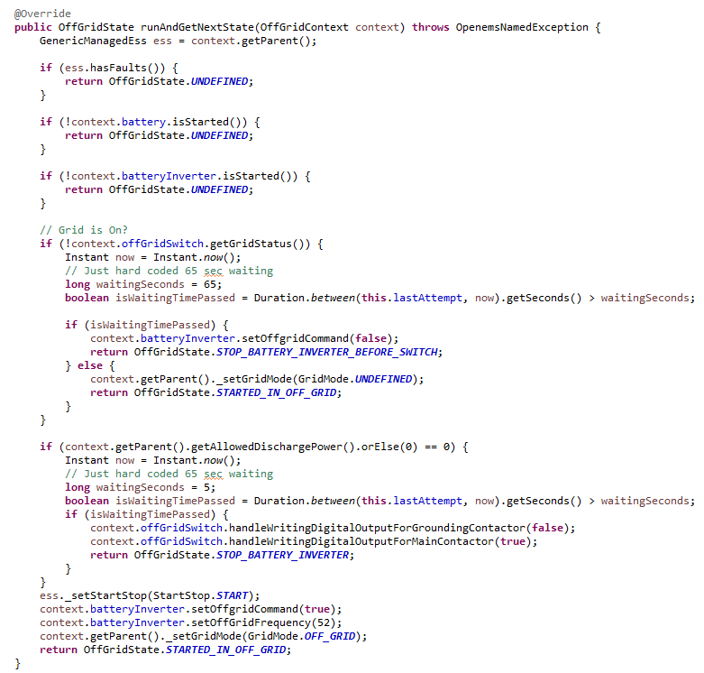

Figure 58 Generic Off-Grid ESS state machine StartedInOffGrid state

### Establishment of data monitoring

In this chapter, the OpenEMS according to the designed architecture with the Generic Off-Grid ESS implementation is loaded and executed on the FEMS with the number 2834. Furthermore, all steps required to achieve the target are presented. For the sake of data security, the password is not specified in this work. This segment also goes into how to configure the individual components in the Apache Felix web console. The data obtained by the FEMS is then stored centrally in the Influx dB database and OpenEMS backend, where it can be retrieved at any time.

#### Load and run the OpenEMS on the FEMS

The Java Eclipse programming environment is used to generate the JAR file that must be executed on the FEMS. To deploy the generated JAR file and run the OpenEMS service, several programs are needed. The JAR file is deployed onto the FEMS using the WinSCP program. To establish an SSH(Secure Shell) communication, which is the protocol that uses encryption to protect the connection between a client and a server [28] via WinSCP, the FEMS IP v4 address, the username, and the password are required.

Table 5 FEMS access data

|  |  |
| --- | --- |
| FEMS Number | fems2834 |
| Ip-Address | 10.0.2.80 |
| Username | fems |

To begin, the SCP transfer protocol must be chosen, which transfers the file in encrypted form. The PC's file directory is on the left side of the program, and the FEMS's file directory is on the right. The JAR file is loaded via "drag and drop" in the usr / lib / openems directory. Figure 59 WinSCP program for transferring the JAR file depicts the WinSCP program used to load the JAR file onto the FEMS.

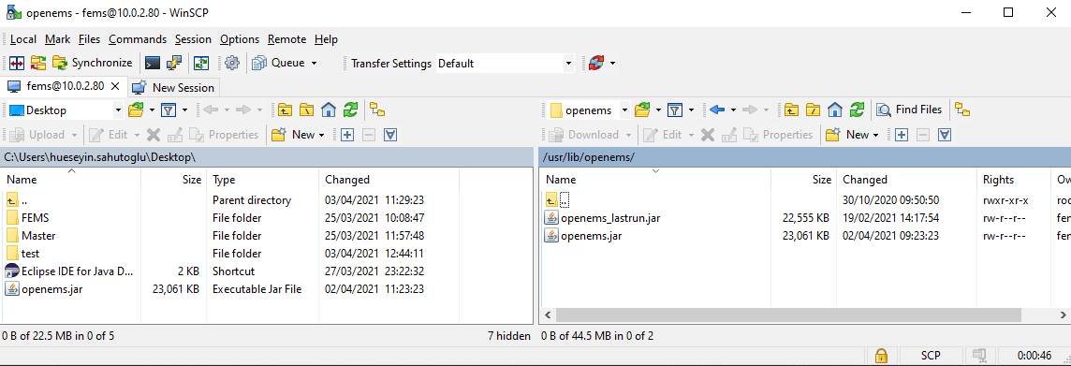

Figure 59 WinSCP program for transferring the JAR file

To execute the JAR file, or in other words to run the OpenEMS service, an SSH connection to FEMS is required. Kitty software is used for this, which produces an SSH tunnel to FEMS and outputs a FEMS terminal. FEMS's IP v4 address, username, and password are needed again, as with WinSCP. OpenEMS can be started by typing "systemctl start openems" in the terminal after entering the access data and the "sudo su" command, which is used to run commands with root permissions with the user password. "journalctl -lfu openems" should be entered. OpenEMS can be started by typing "systemctl start openems" in the terminal after entering the access data and the "sudo su" command, which is used to run commands with root permissions with the user password. "journalctl -lfu openems" should be entered.

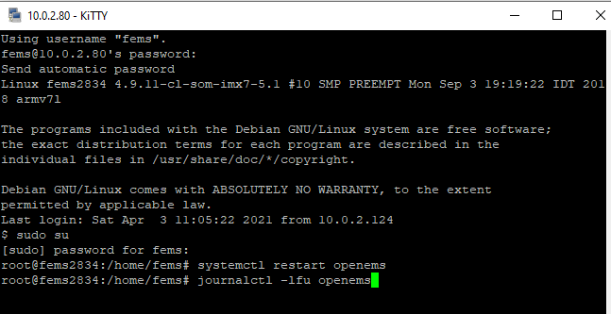

Figure 60 Entering the commands in the Kitty console

A tunnel to the FEMS must now be opened in order to gain access to the web interface, i.e., the Apache Felix web console. An SSH tunnel to the FEMS is set up under “Change Settings”, “Connections”, “SSH” and “Tunnel”. It receives the port number 8089 whose destination is "localhost: 8080". In principle, the port number 8089 can be freely selected, but it must be greater than 8000. The SSH tunnel is configured by adding. With the URI "http: // localhost: 8089 / system / console / configMgr" access via an Internet browser is possible. The necessary configurations of the OpenEMS must now be made in this list so that the energy storage system works. The following sections deal with the configuration of the individual components of the Apache Felix Web Console.

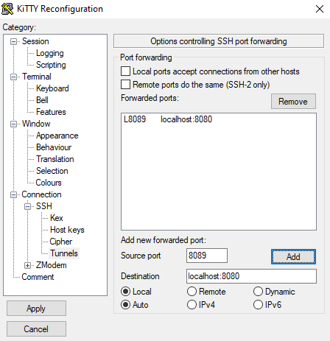

Figure 61 Kitty SSH tunnel configuration

#### Basic Apache Felix web console configurations

The first important setting is the activation of the "Scheduler All Alphabetically". It cyclically executes all configurations made in the Apache Felix web console. Prioritisation of the controllers also configured here. The cycle time must now be set in the “Scheduler All Alphabetically”. The setting is saved with "Save".

Figure 59 Modbus RTU bridge for battery shows the configuration of the RS-485 serial bus. This communication interface is intended for the electrical storage. The communication interface receives the Modbus ID "modbus0", which is again important for the later configuration of the electrical storage. Furthermore, the USB port of the FEMS is specified and the baud rate as well as the number of data bits, the number of stop bits and parity are set. The configuration is saved with "Save". The electrical storage can now be configured.

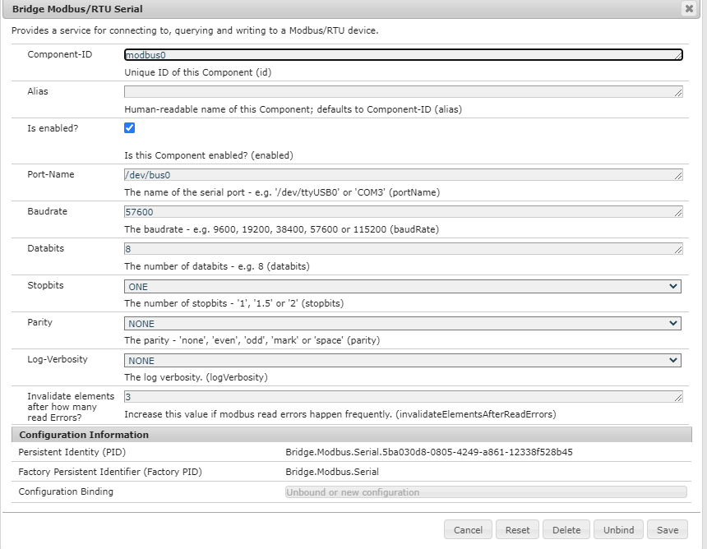

Figure 62 Modbus RTU bridge for battery

For this, the "BMS Soltaro Single Rack Version C" is activated and receives the ID "battery0". At this point, the Modbus ID of the RS-485 bus should be set as modbus0, the unit ID should be 1, module type of the battery should be MODULE_3_5_KWH, number of used modules in the battery is 9, watchdog set as 60 seconds, and the start stop behaviour due to the fact that it will be controlled via Generic Off-Grid ESS it should be set to AUTO. The following figure shows the settings made.

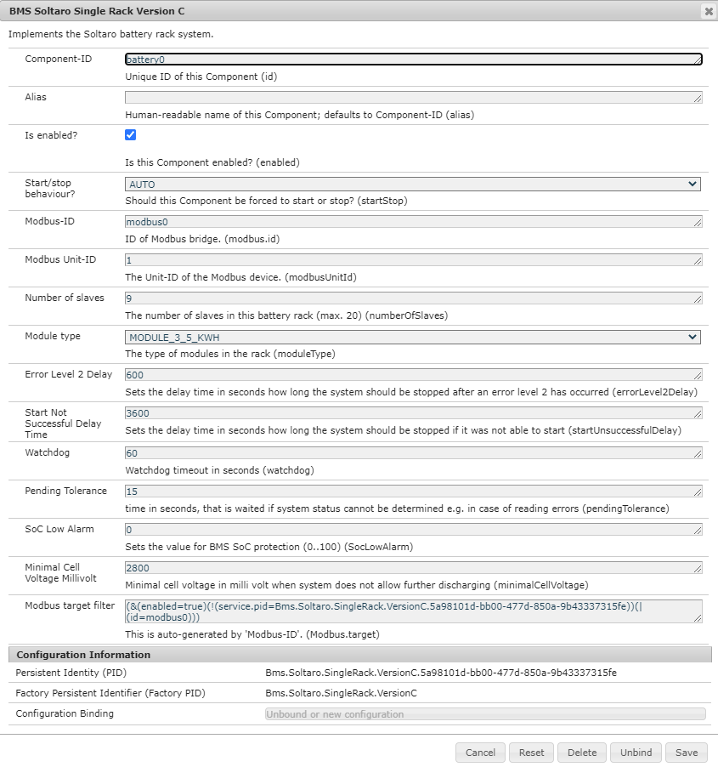

Figure 63 BMS Soltaro Single Rack Version C battery configuration

Then, to establish a communication between FEMS and battery inverter FEMS must be in the same IP address range as the battery inverter, so FEMS's network settings must be configured before the Modbus TCP bridge is installed. Since Sinexcel has a static IP v4 address of 192.168.1.11, the IP v4 address chosen for FEMS is 192.168.1.10. FEMS network configuration can be accomplished by editing the systemd network file with the "vi /etc/systemd/network/eth1.network" command on the terminal, as shown below.

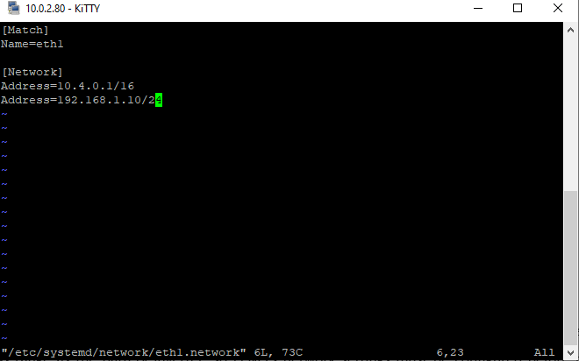

Figure 64 FEMS systemd network configuration for battery inverter

The configured Ip v4 address can be viewed on the terminal by using the "ip addr" command.

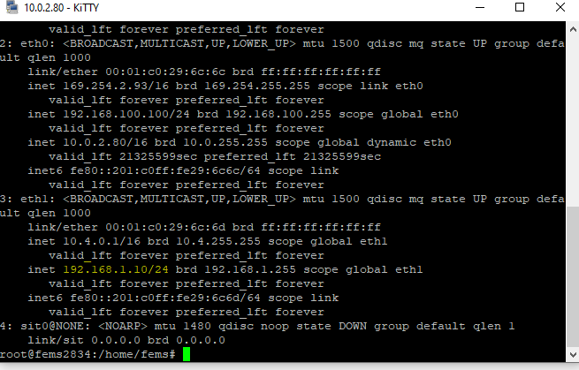

Figure 65 Configured FEMS IP address on eth1 for battery inverter

The "Bridge Modbus/TCP" component is configured for this purpose and receives the battery inverter's "modbus2" ID and IP address.

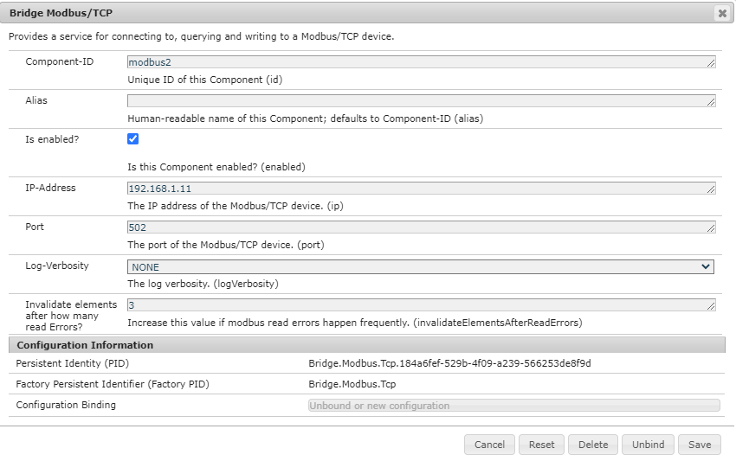

Figure 66 Modbus TCP/IP bridge for battery inverter

For the battery Inverter configuration, “Battery-Inverter Sinexcel” component can now be activated with the component identity "batteryInverter0," and given bridge modbus2, which refers to the Modbus-TCP link. Start-stop behaviour should be set to AUTO as well.

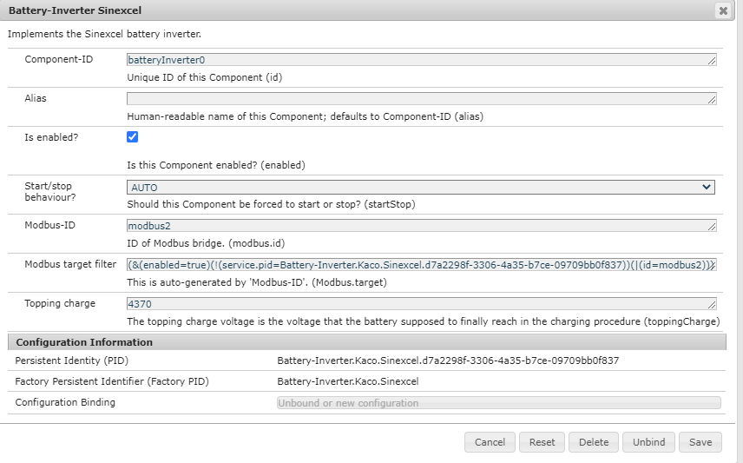

Figure 67 Battery-Inverter Sinexcel configuration

Since the Wago fieldbus coupler has a static IP v4 address of 192.168.1.50, which is also in the same range as Sinexcel and FEMS, the network settings do not need to be reconfigured. So, second Modbus TCP/IP bridge can be created for Wago fieldbus coupler communication as it shown below Figure 68 Modbus TCP/IP bridge for Wago fieldbus coupler with component id “modbus3”.

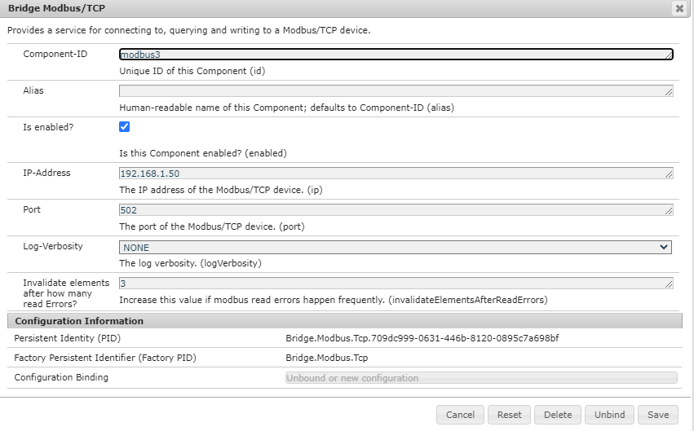

Figure 68 Modbus TCP/IP bridge for Wago fieldbus coupler

IO Wago fieldbus coupler 750-352 component can be activated now, and input-output channels mapping can be configured in IO Off Grid Switch component which can be seen configuration details below in Figure 69 IO Wago Fieldbus Coupler 750-352 component configuration and in Figure 70 IO Off Grid Switch component configuration.

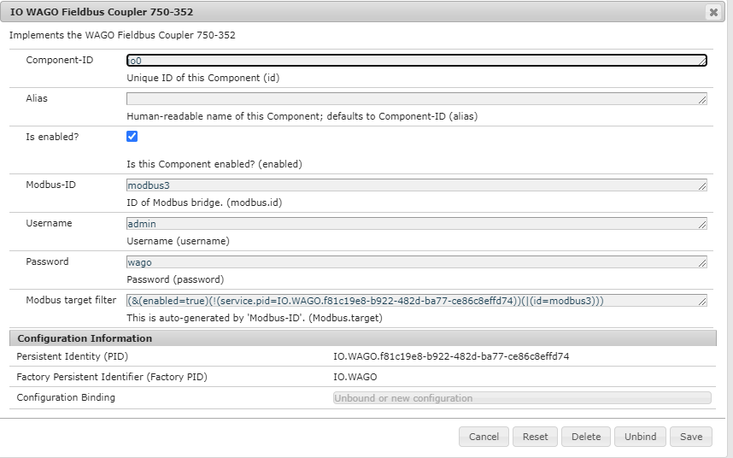

Figure 69 IO Wago Fieldbus Coupler 750-352 component configuration

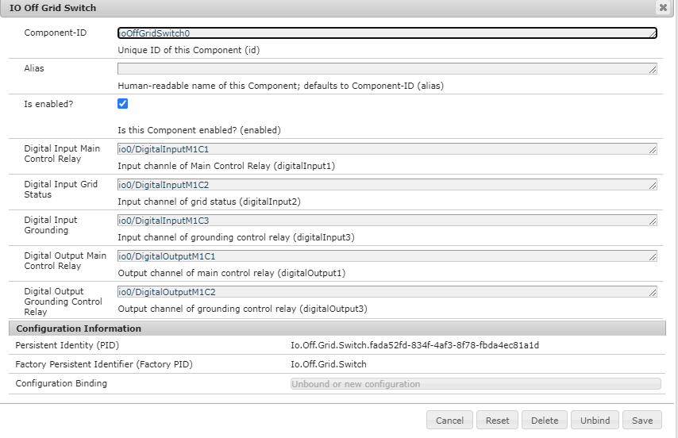

Figure 70 IO Off Grid Switch component configuration

Now, gathering all components under a roof, to control centrally by, Generic Off-Grid ESS can be configured as shown below in Figure 68 ESS Generic Off-Grid component configuration. Start-stop behaviour is enabled in order to operate and monitor the battery and battery inverter, component configuration is required, and two additional significant configurations are provided, one of which is allowed minimum SOC in off grid and the other is allowed minimum cell voltage in off grid. As explained in the Generic Off-Grid ESS state machine, in the event of a grid failure, safety of the battery should be taken care of before running it. As a result, if one of those values is equal to or greater than the current battery SOC or minimum cell voltage, the stop sequence is activated, and the battery shuts down.

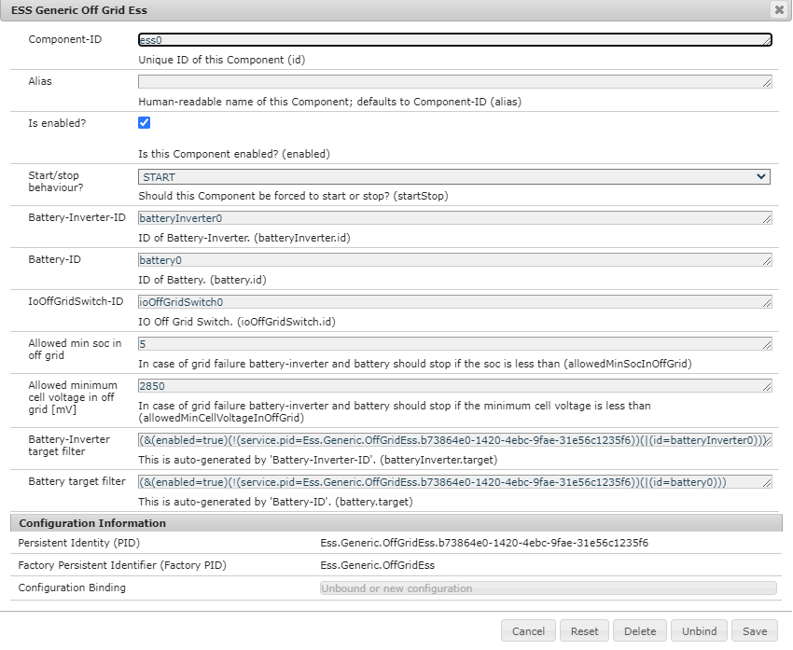

Figure 71 ESS Generic Off-Grid component configuration

The part “ort.ops4j.pax.logging” is used to output the configuration of the console output as well as general details such as the time. It is a standard setup that only needs to be turned on. When the “Debug Log” controller is activated, the basic parameters of the energy storage device are output. With the "ESS Power" option enabled, for example, power restrictions are allowed due to the controller's later activation. This portion also manages the power distribution of multiple energy storage systems that have been cascaded to form a large energy storage system. If all of the basic configurations have been completed, it is recommended that OpenEMS be restarted to ensure that the improvements made are implemented correctly. This can also be accomplished by typing “systemctl restart openems” into the Kitty console. After the restart, the electrical storage turns on, and the inverter comes on after about a minute. Furthermore, critical parameters such as current, voltage, input-output Wago channels, inverter state as well as AC power and inverter status, are displayed in the Kitty console. depicts the results of the parameters entered.

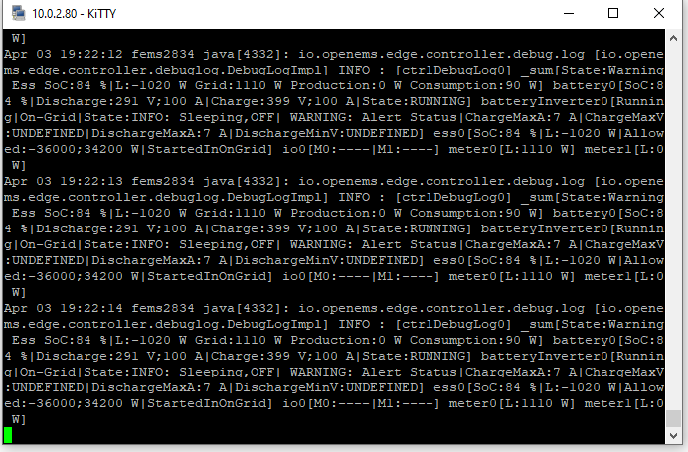

Figure 72 OpenEMS service debug log in Kitty

Since the implementation is now running on the FEMS and reading data, these must now be stored centrally in Influx dB database. The next section describes the necessary configurations in the Apache Felix web console.

#### Configuration for the OpenEMS backend and OpenEMS UI

The data that OpenEMS receives from the energy storage system must now be stored centrally. There are two data paths available for this. The first way is for the FEMS to send the data to the OpenEMS UI. A web socket protocol is used here, which allows requests to be sent to the FEMS in order to receive the data from the energy storage system. A WebSocket is a connection that allows bidirectional requests between a web application, the OpenEMS UI, and a web server that allows FEMS. The WebSocket is based on the HTTP network protocol. In order to establish a bidirectional connection with the OpenEMS UI, the activation of the "Api WebSocket" controller is necessary. The port number 8085 and an API timeout of 60 seconds must be set there. The channel information is queried every minute and displayed in the user interface.

The second data traffic takes place between the OpenEMS backend and FEMS. In addition, the data from the backend is sent back to the OpenEMS UI via the WebSocket protocol. In contrast to the OpenEMS UI, the collected data can be called up retrospectively in the OpenEMS backend. In order to set up a connection between the FEMS and the backend, the "Api Backend" controller must be configured. An API password, the URI of the backend, the cycle time for sending the data to the backend, the network protocol and the API timeout are required. The following figure shows the configuration of the "Api Backend" controller.

Now the FEMS sends the data of all components to the OpenEMS backend. With Grafana, the data can be called up from the backend and recorded and documented over time.

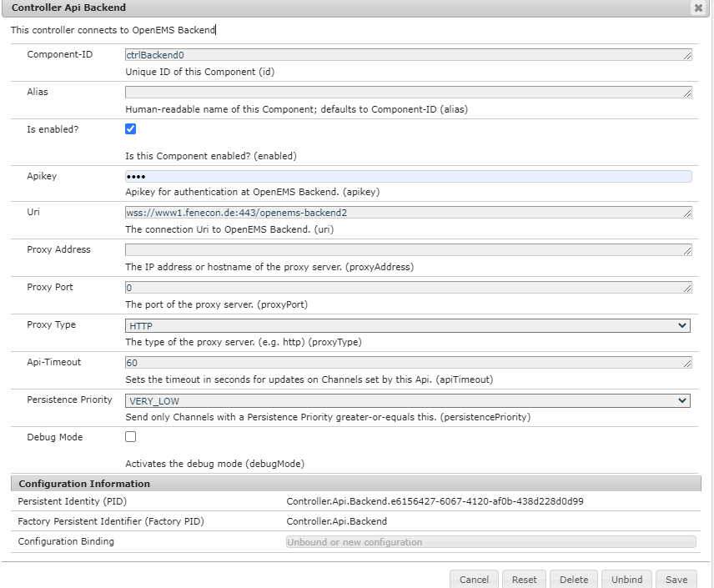

Figure 73 Configuration of OpenEMS Backend connection

#### Other controller configurations

There are several controllers in the Apache Felix web console that can be activated to extend the energy storage system. The "Fix Active Power Symmetric" controller is used for basic energy storage device loading and unloading. The inverter's ID and power must be defined in order to accomplish this. Negative values cause the energy storage device to charge, while positive values cause it to discharge. The entered value is passed directly to the "apply-Power" method, converted, and written to the inverter's relevant register. The controller “Ess Cap Total Discharge” protects the energy storage system from deep discharge. To accomplish this, the inverter's ID and the SOC value at which the discharge is blocked must be defined once more. If the device is not charged for an extended period of time, the storage unit continues to discharge from the attached inverter, which draws energy from the storage unit in part. To avoid this, a second SOC value is provided in addition to the minimum SOC information, at which the energy storage system is charged with one-fifth of its maximum output. To do this, the "Min SOC" must be greater than the "Force-Charge SOC." If applicable, the charging power may also be defined. Figure 71 Controller ESS Total Discharge configuration depicts the "Ess Limit Total Discharge" controller's configuration. It should be noted that this controller only makes sense in the presence of a network; if there is no grid, the settings made in the Generic Off-Grid ESS part for battery safety will be triggered, and the system will be switched off.

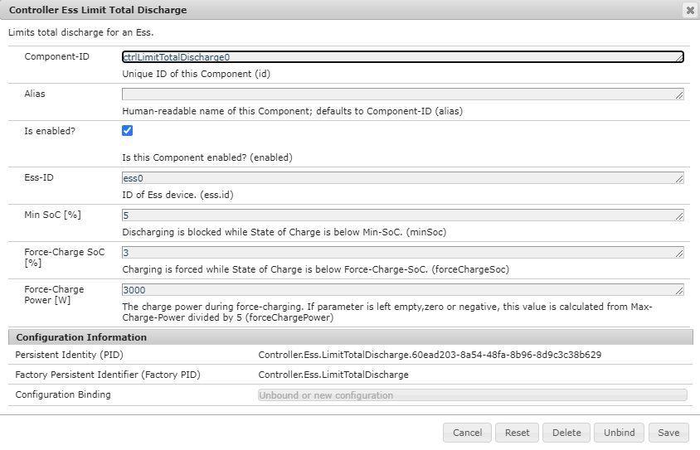

Figure 74 Controller ESS Total Discharge configuration

With the “Balancing Symmetric” controller, the energy storage system will optimize the internal consumption of the house. To do so, however, a 3-phase grid meter that calculates power and its path on the meter must be configured. In this case, the meter used to calculate efficiency is the SOCOMEC Diris A14, which is already implemented in OpenEMS and can thus be configured in the Apache Felix web console. The Modbus-RTU connection to the measuring system must be configured first. Next, the grid meter must be configured. It receives the "meter0" as component Id and refers to the Modbus-RTU connection of "modbus1". The following figure shows the selected settings.

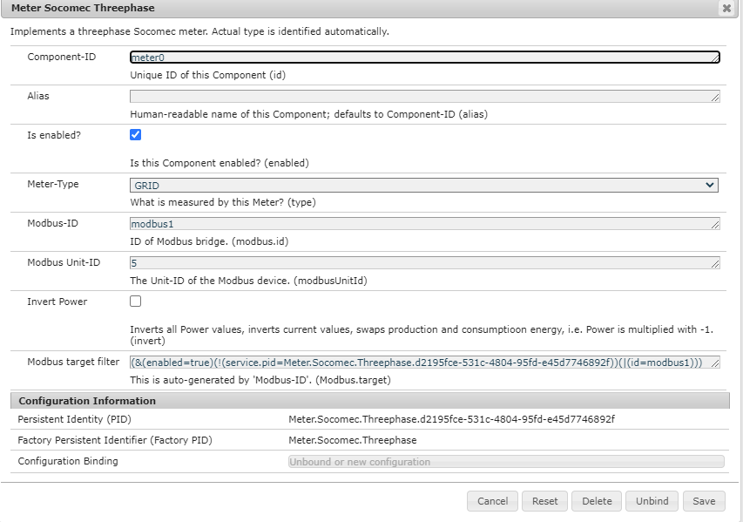

Figure 75 Configuration of grid meter

The “Balancing Symmetric” controller can now be activated. Only the ID of the inverter "ess0" and the ID of the grid meter "meter0" have to be entered. It is also important that the controller "Fix Active Symmetric Power" is deactivated, otherwise two different values are transferred to the "applyPower" method. The grid meter now measures the power on the meter and adds it to the current power of the inverter. The result is then transferred to the inverter's "applyPower" method. The inverter compensates for the measured power.

# Evaluation and test

Now that the energy storage system is ready, testing will begin using the pre-planned test protocol. The procedure begins with a visual inspection of the device to check the wiring and any external damage. The following move is to activate the energy storage system. To accomplish this, OpenEMS is started on FEMS, and electrical storage is activated via the battery manual control switch. Since the initial state till inverter is ready to operate will shown step by step. After a short period of waiting, the inverter is able to charge or discharge the storage device. First, a Grafana dashboard must be built that pulls data from the OpenEMS backend and displays it in a diagram. The current state of the inverter, cell differential voltage and the specified maximum charge and discharge current of the BMS are displayed in numbers.

The project's test phase includes important points such as system control with the aid of the state-machine, state shift of the state machine, behaviour of the system in case of communication problem ,changes between the public grid and the micro grid, and battery safety when allowed discharge power is 0. It was mentioned that the created state machine's initial state was Undefined. The grid is available, the main relay is closed, and the ground contactor is open in the figure below, and all situations are undefined at the start.

.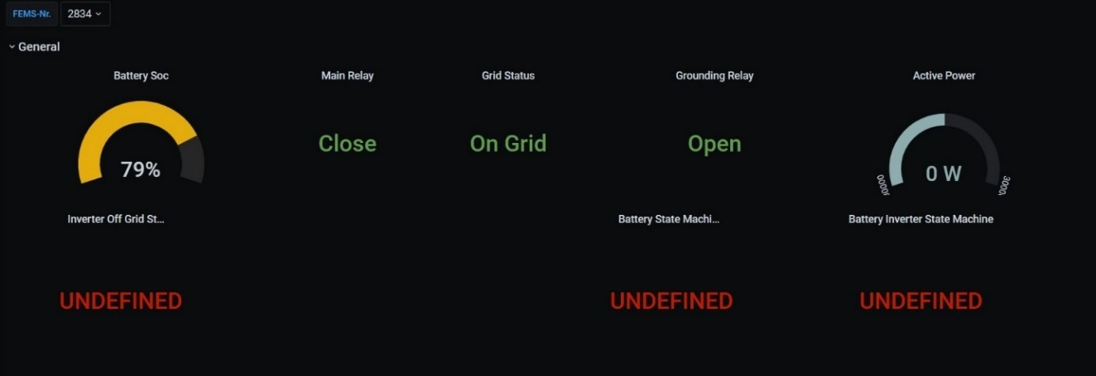

Figure 76 Initial state, running in on-grid mode

The next condition, as planned, is "Grid Switch," and because the relays are in the desired place and the public grid is also present, the next phase is expected to begin by starting the battery on the on-grid. The state changes made with starting the battery and battery inverter are depicted in the figures below.

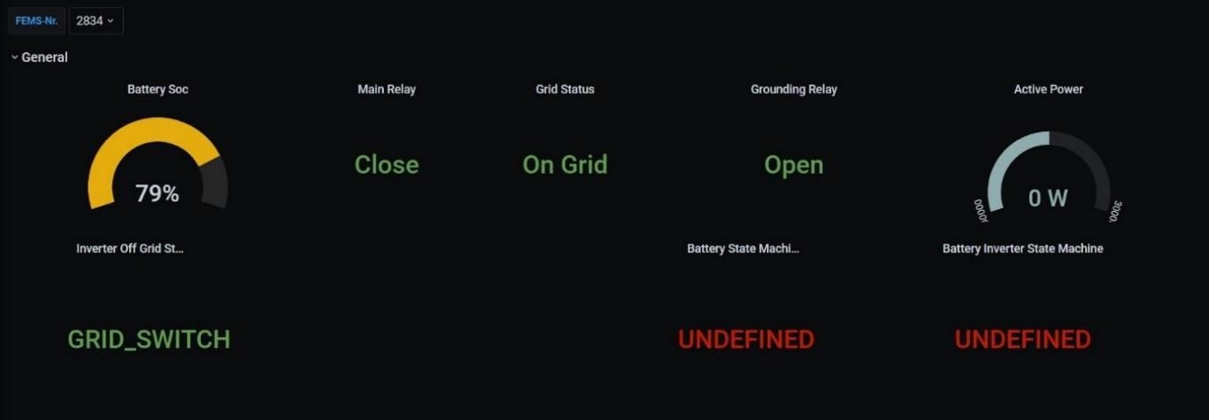

Figure 77 Grid switch state decision maker

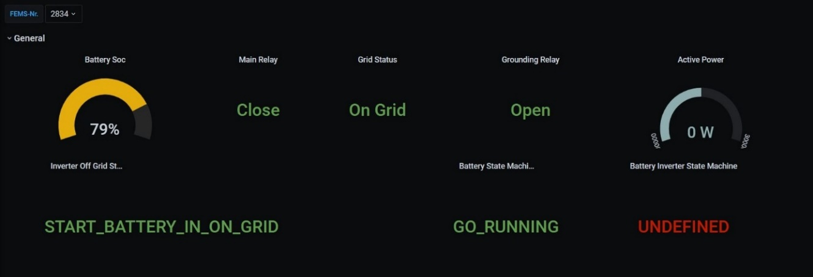

Figure 78 Start battery in on-grid

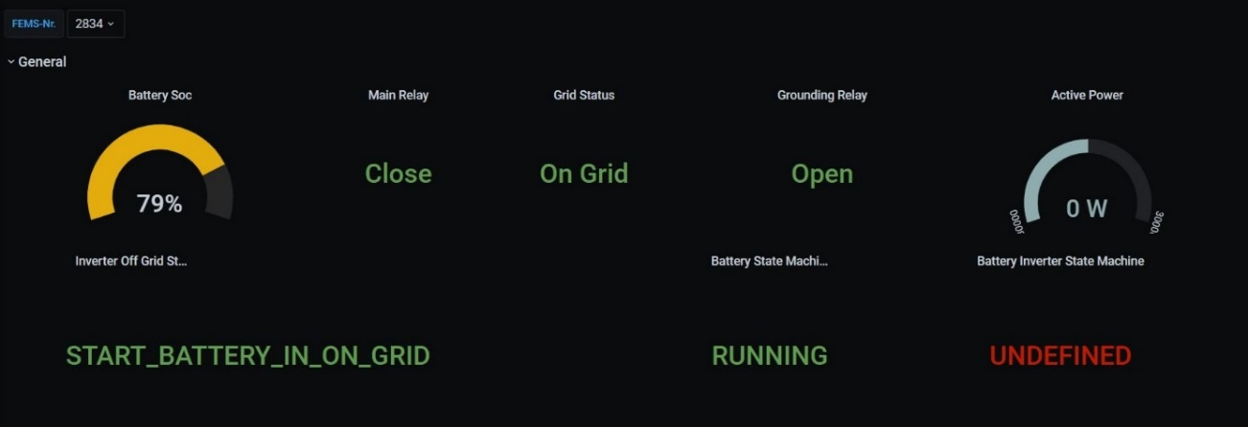

Figure 79 Battery started in on--grid

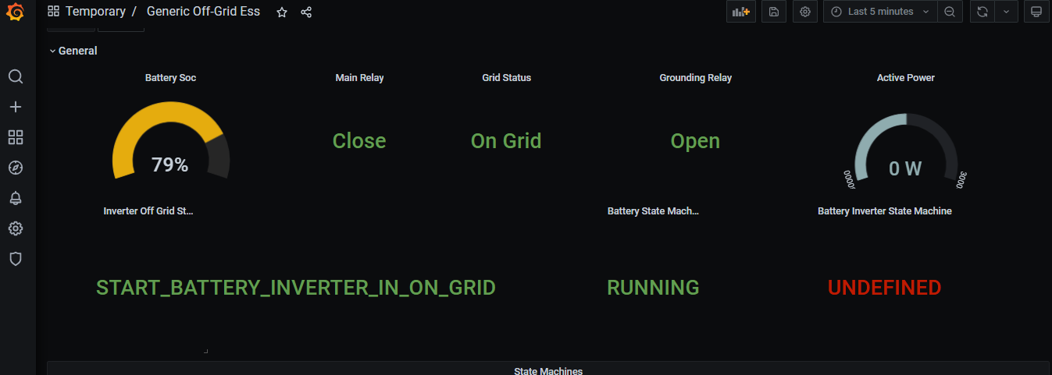

Figure 80 Start battery inverter in on-grid

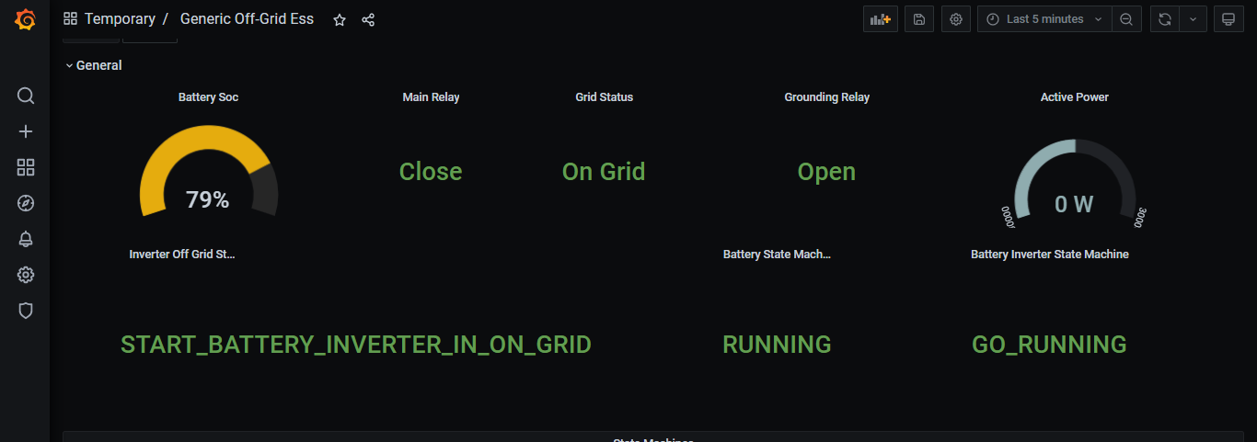

Figure 81 Starting battery inverter in on-grid

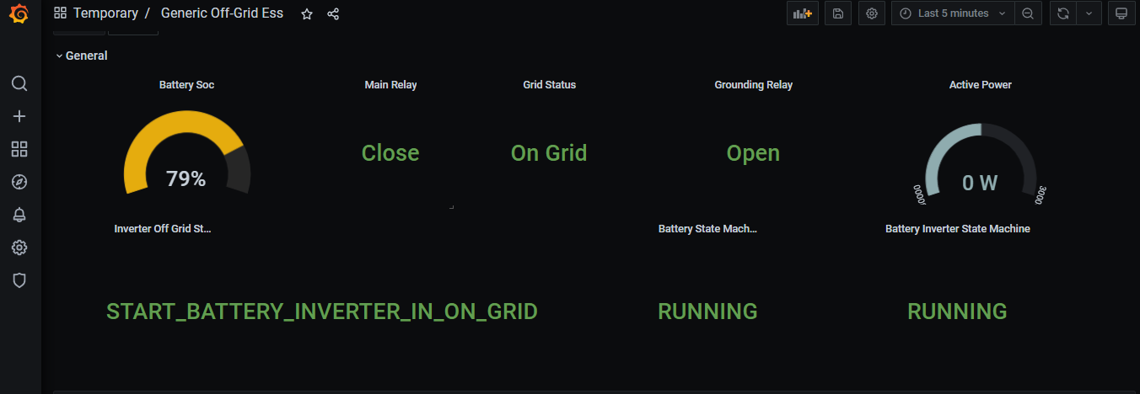

Figure 82 Battery inverter started in on-grid

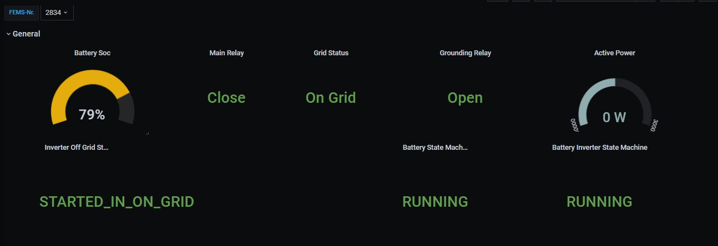

Figure 83 System is running in on-grid

Since the system's start-up in the on-grid state has already been tested and verified, the next phase would be the on-grid to off-grid transition test. Off-grid status will also be tested with the Figure 18 ABB S203-B10 Miniature Circuit Breaker - S200 - 3P - B - 10 ampere [20] which has the F5 label specified in Figure 23 Under voltage detection and main relay , by disconnecting the public grid from the system. The grid status graph below indicates that the grid status has switched to off-grid and main relay switched off automatically. The grounding relay is still open. The battery inverter will be stopped first before switching the relay positions and re-starting the battery inverter. There will be no state changes on the battery since it is still in operating mode. The figure below shows how states change step by step before the device begins to run in off-grid mode.

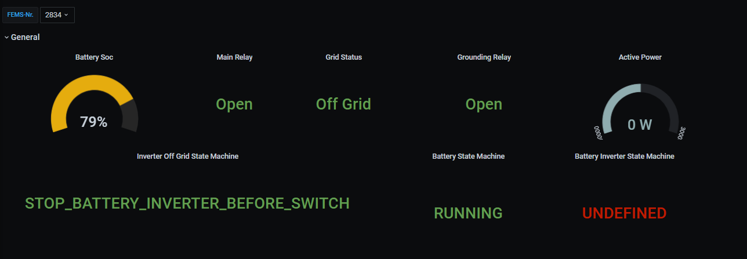

Figure 84 Stop battery inverter before switch to off-grid mode

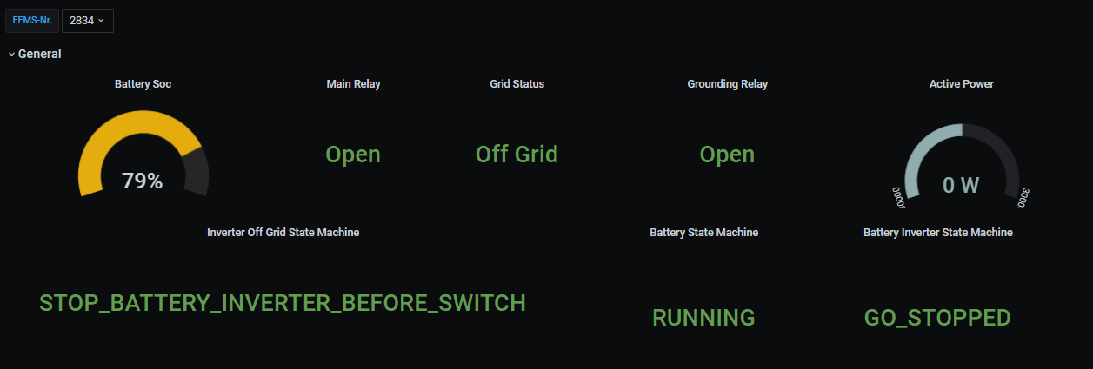

Figure 85 Stopping the battery inverter before starts in off-grid

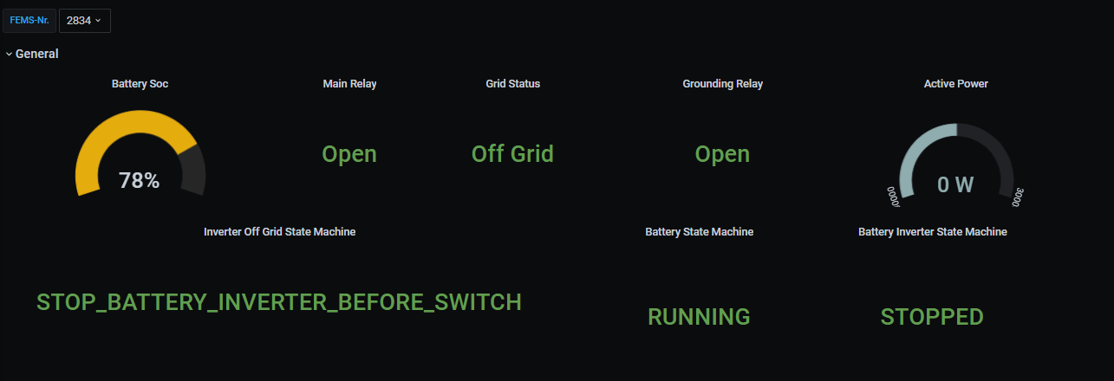

Figure 86 Battery inverter stopped

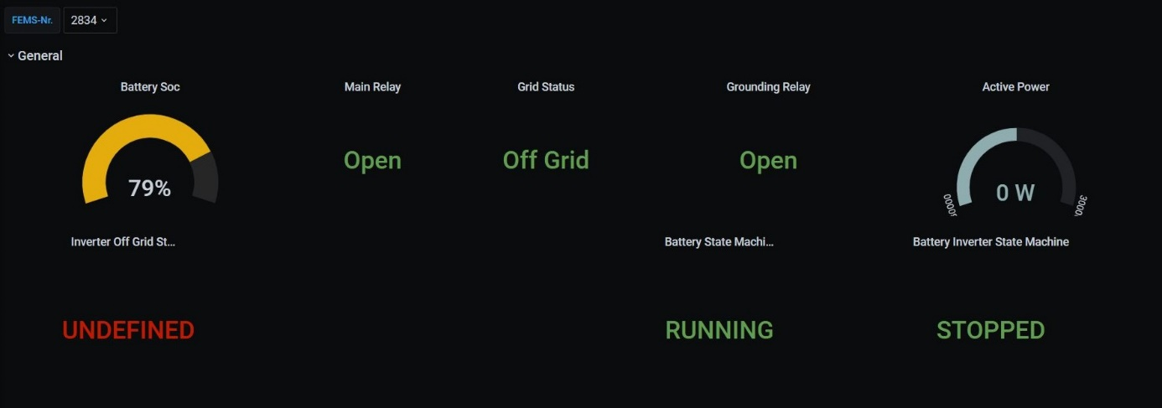

Figure 87 Battery inverter stopped, and state is undefined

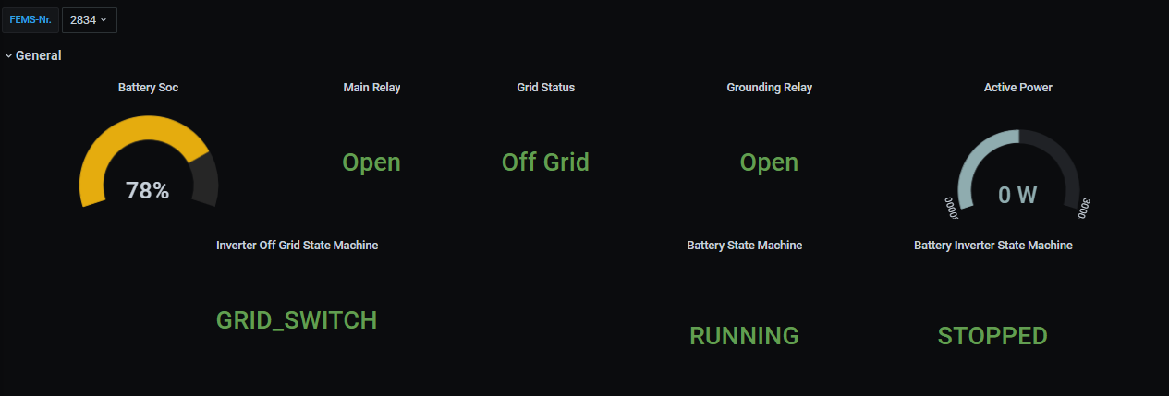

Figure 88 Relay switching, and decision mechanism applied in grid switch

Ground relay closed and next state to start the battery in off-grid mode.

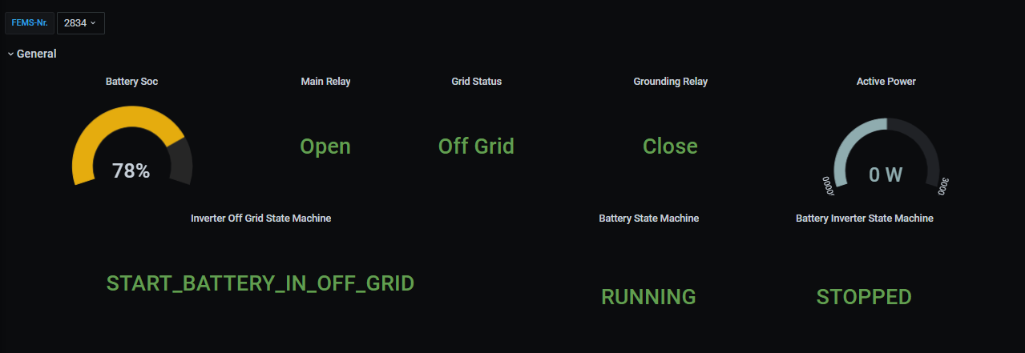

Figure 89 Battery started in off grid

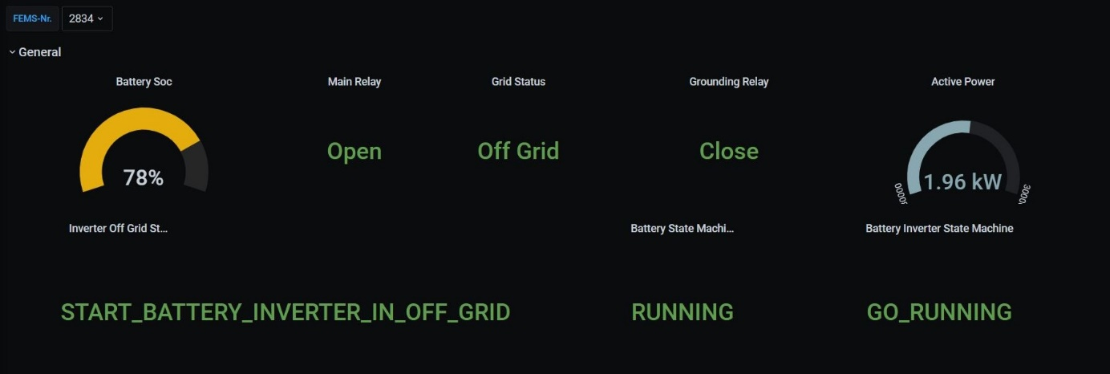

Figure 90 Battery inverter is starting in off-grid

teasm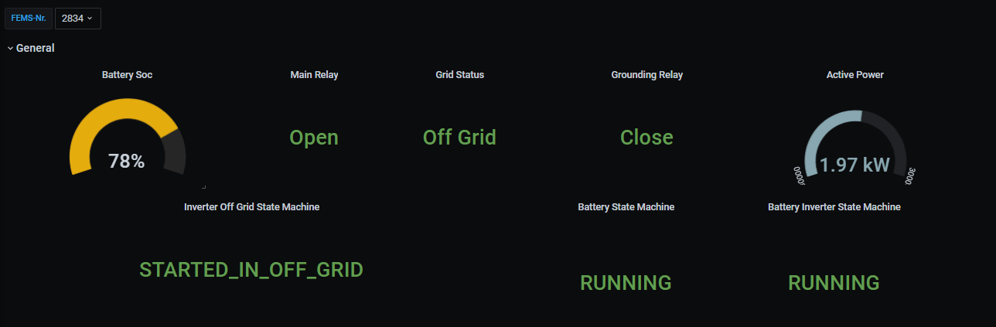

Figure 91 System started to operate in off-grid

When the system is in off-grid mode and a 2kW load is connected, the battery discharge has a power of 1.97kW. After the system's on-grid mode has been checked, the process will be reversed, with the transition from off-grid mode to on-grid mode being the next test phase. Similarly, if a grid connection is possible, 65 seconds will elapse before the battery inverter is turned off.

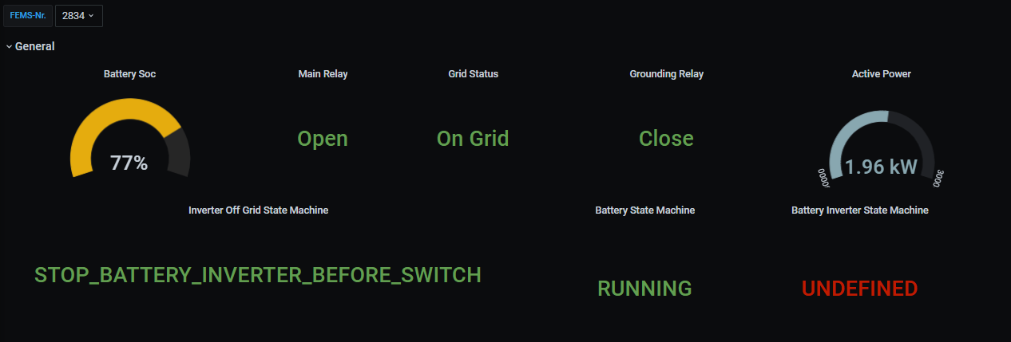

Figure 92 Stop battery inverter before grid while going to on-grid

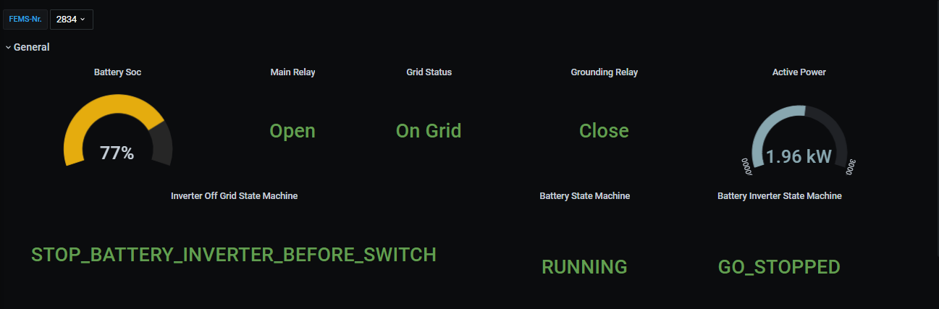

Figure 93 Battery inverter is going to stopped

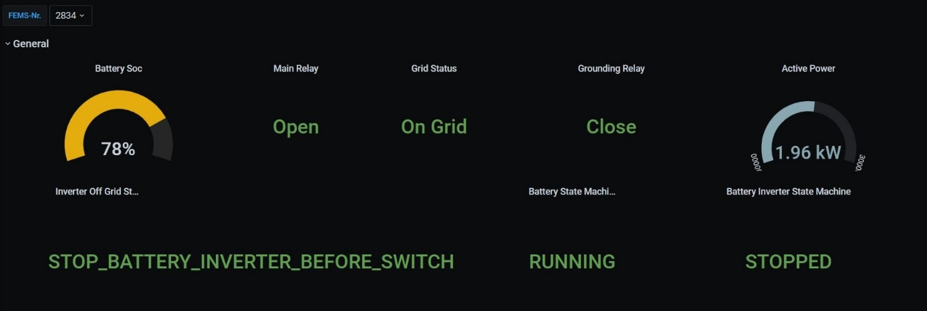

Figure 94 Battery inverter stopped

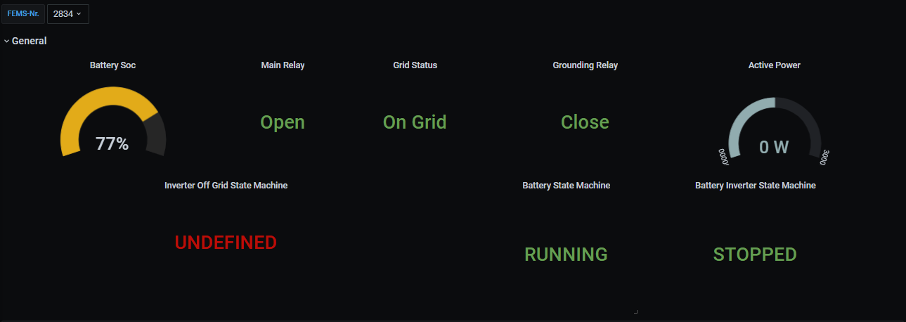

Figure 95 While going on-grid , battery inverter stopped, and state is undefined

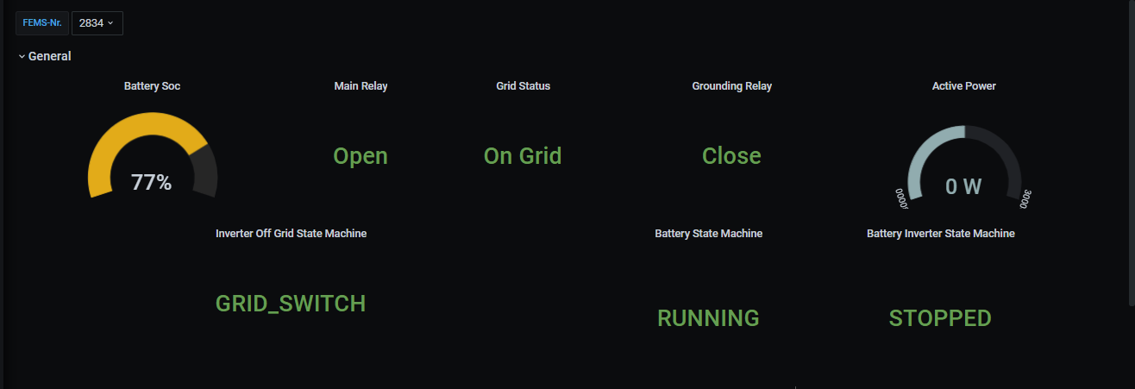

Figure 96 Before Start the battery inverter, adjust relay position in Grid Switch state

By comparing relay status with the figures below and above, the location of the relays in the "Grid Switch" state was adjusted prior to "start battery in on-grid" state.

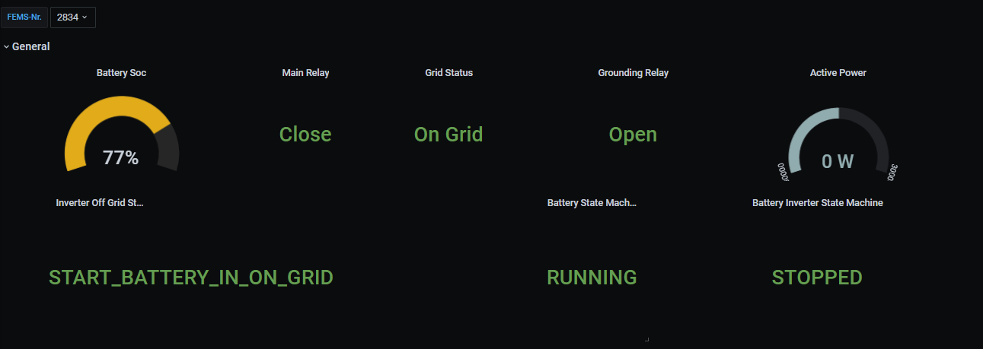

Figure 97 Start battery in on-grid

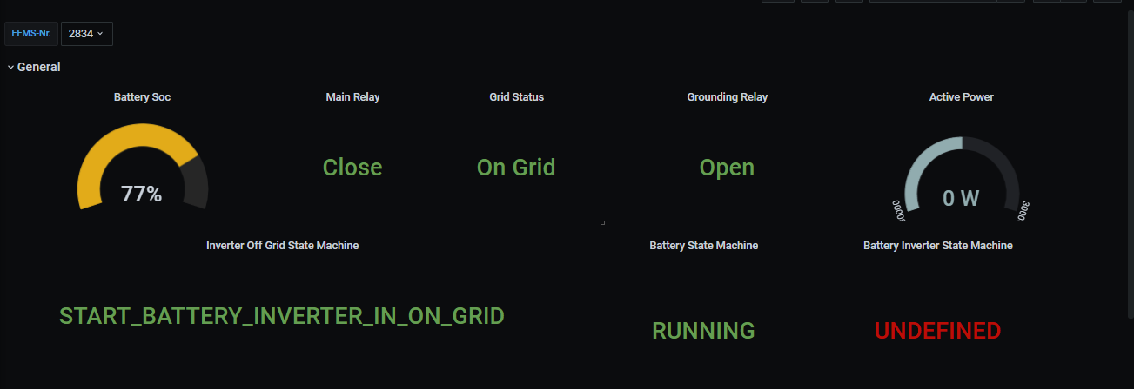

Figure 98 Start battery inverter in on grid first state Undefined

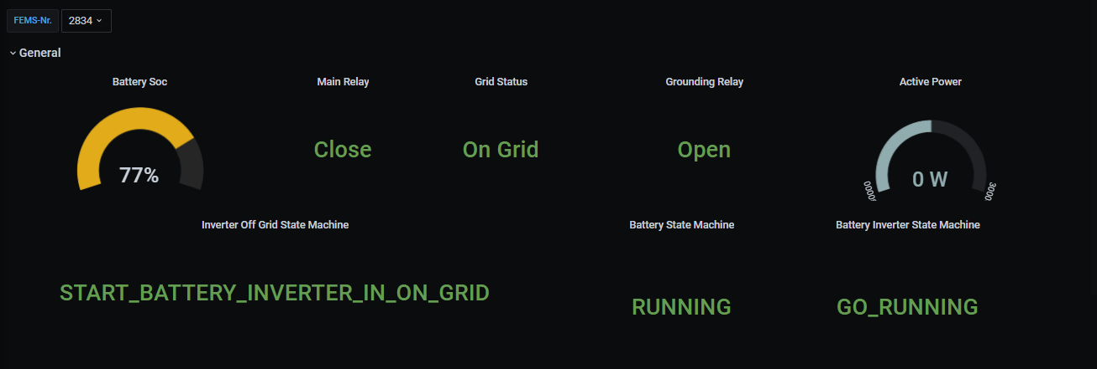

Figure 99 Battery inverter is starting in on-grid

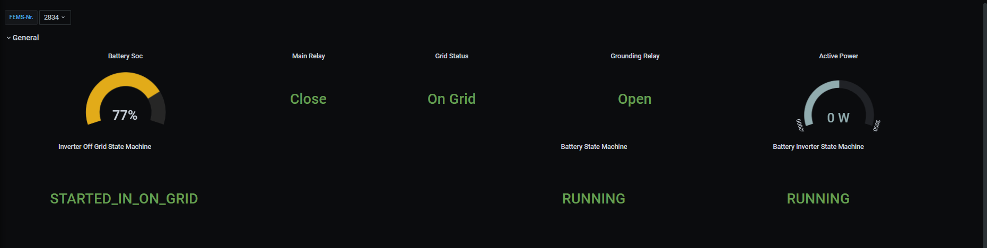

Figure 100 System started to operate in on-grid mode

The next test phase will be to stop the battery if the battery operating in the off-grid state falls to 0 W allowed discharge power. In order to better understand the given Grafana state machine dashboard, the values of the state machine states are given below. While -1 represents “Undefined” state in Grafana dashboard, 22 will stands for “Started In Off Grid” state, 30 for “Stop Battery Inverter” state, 41 for “Grid Switch” state, 10 for “Start Battery In On Grid” and 12 for “Started In On Grid”.

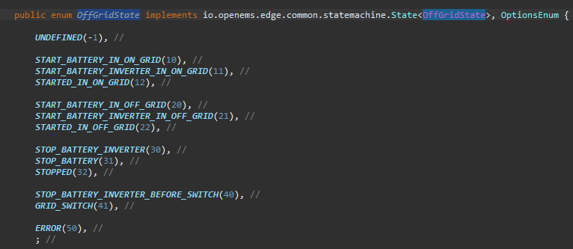

Figure 101 Enum values of off-grid state machine states

In the figure below, it is seen that the allowed discharge power was 9633W, was discharging with 4kW of power due to the connected loads and “Generic Off-Grid ESS State Machine” channel was 22 which means the system was operating on off-grid.

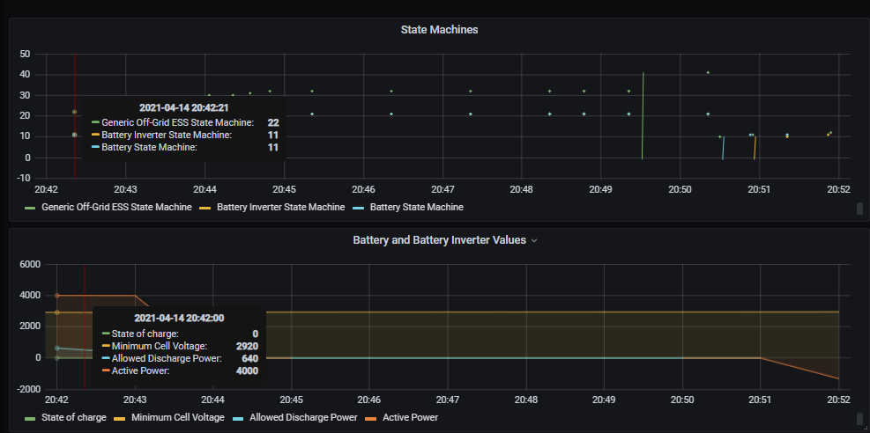

Figure 102 Battery % runs in off-grid

When the battery drops to 0W allowed discharge power, the stop sequence is triggered, and the “Generic Off-Grid ESS State Machine” is changes to 30 which is “Stop Battery Inverter” state and battery inverter is stopped first.

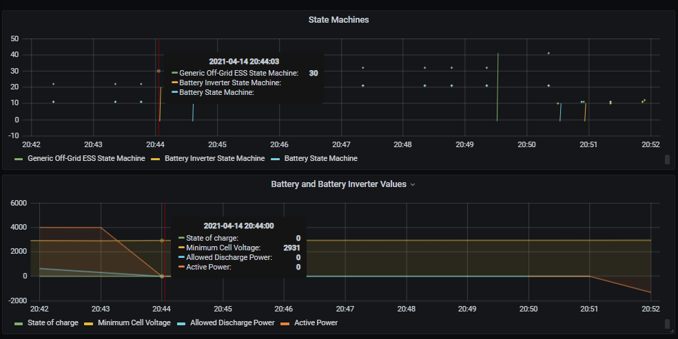

Figure 103 Battery SOC is 4% and stop sequence is triggered

After the battery inverter is stopped and power is not supplied anymore, the battery is stopped as the next step. “Generic Off-Grid ESS State Machine” value is 32 which is “Stopped” state.

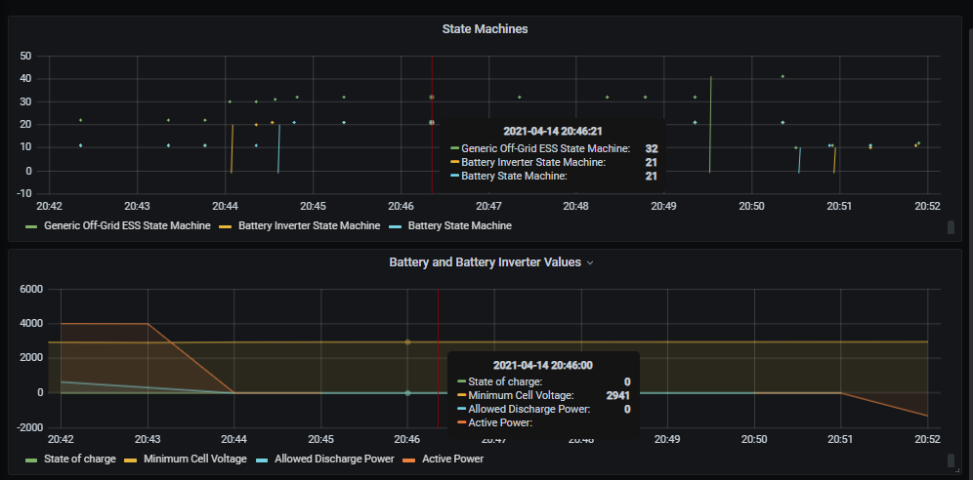

Figure 104 Battery SOC is 4% and battery inverter is stopping

It is observed that the system is completely stopped, and all contacts are open. Thus, the battery is protected and the situation that it cannot be started again due to the deep discharge of the battery is prevented. As a next scenario when the system connected to public grid and if the system shutdown before, restart of the system tested.

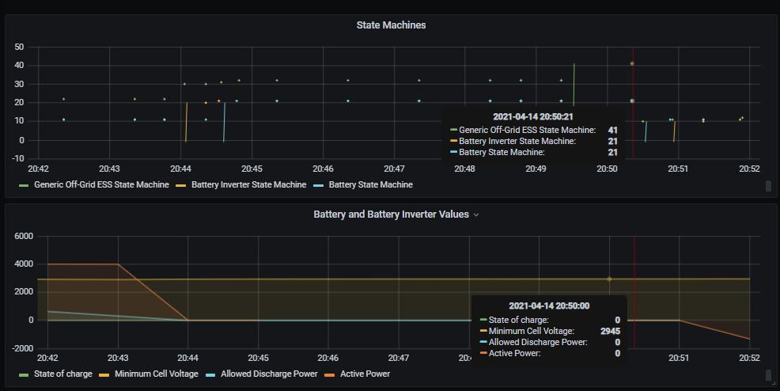

Figure 105 Re-start of the system when public grid available

The shutdown of the system in operation as the next and last test has once again been tested with changing the start-stop target in Generic Off-Grid ESS configuration from start to stop.

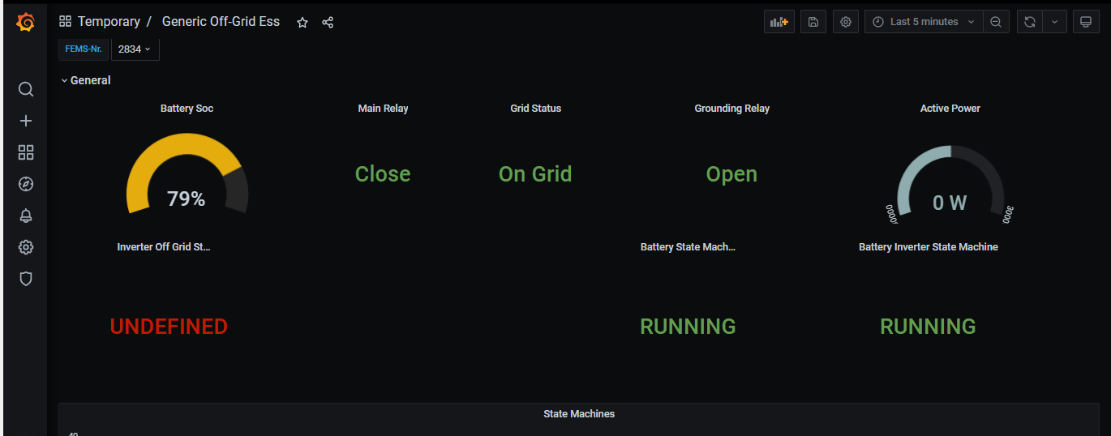

Figure 106 Target Stop, first state is Undefined

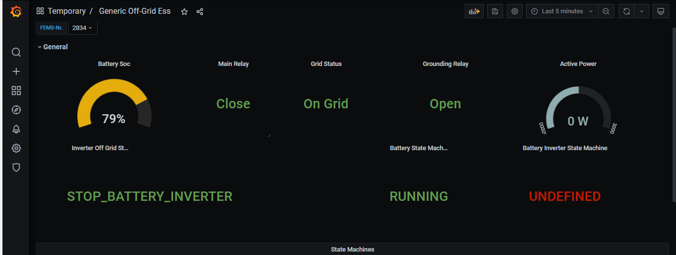

Figure 107 Target stop, battery inverter is stopping

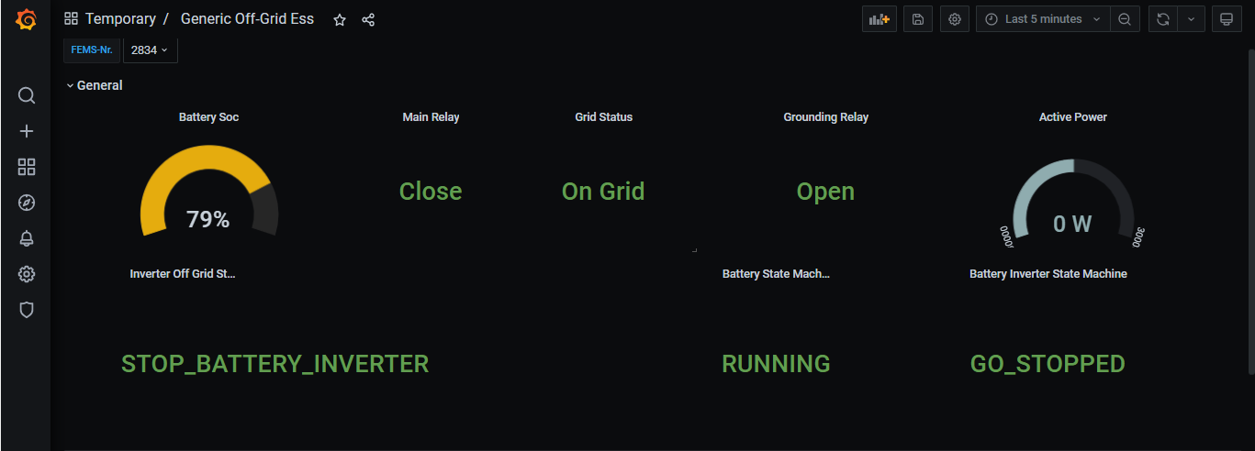

Figure 108 Stopping sequence battery inverter go stopped state

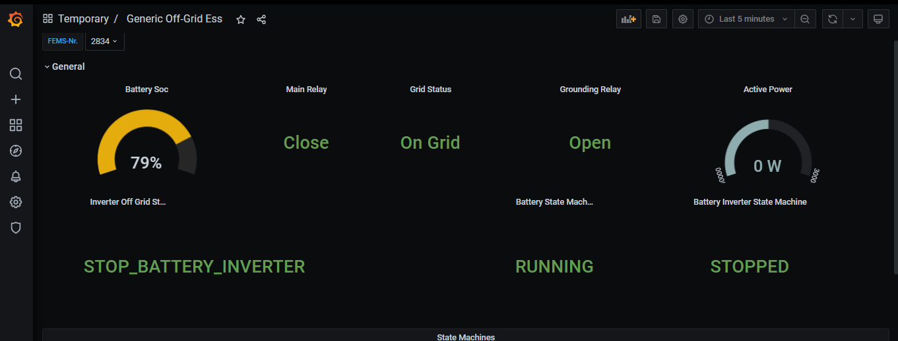

Figure 109 Stop sequence battery inverter stopped

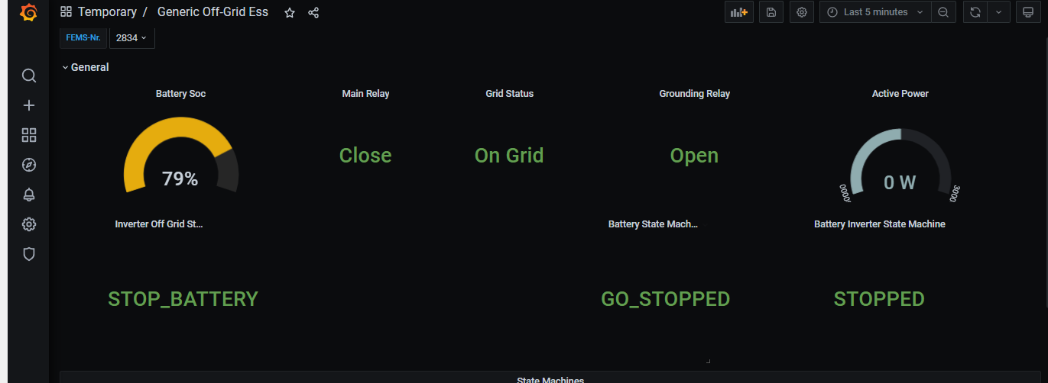

Figure 110 Stop sequence battery is stopping

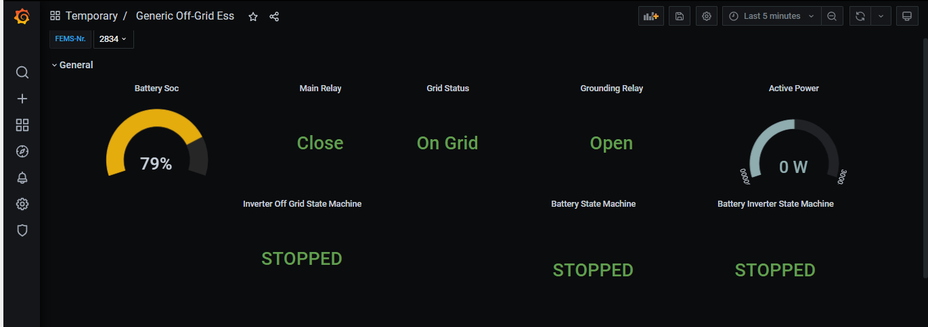

Figure 111 The system is shutdown

# Summary / conclusion / outlook

FENECON's fixed storage system Commercial 30/30 is a product extension for consumers running a small business. In addition to providing storage energy to consumers, a backup solution that meets the needs of customers from public grid to micro grid and vice versa has been added to the industry's qualification standard. Thus, in addition to providing features such as less manual intervention, automatic network switching, the basis was established for applications such as adding PV inverters and diesel generators. The use of "Generic Off-Grid ESS" in OpenEMS successfully fulfilled its goal of providing a general context for off-grid inverters. The company has incorporated a security feature in addition to the four main pillars listed below, which serve as the backbone for the storage systems.

* PV Self-Consumption
* Active energy management
* Grid services
* Participation in the market
* **Security:** an emergency power grid can be made available by extending the photovoltaic system with an energy storage unit. For each individual user, the requirements for emergency power are different. FENECON offers special solutions for security requirements from uninterrupted power supplies to island capacity for agriculture, or trade.

With the device with a capacity of 30 kWh, a new capacity range was added to the industry, in addition to applications in the industry with low voltage capacity of 5 to 20kWh and medium voltage capacity of 50kWh and GWh. An alternative in personal applications was given to the consumer by providing the versatility of transitioning between mains electricity and micro grid. With the extension of the OpenEMS Edge architecture, it has been possible to add new controls for off-grid inverters. In addition to all flours, components can be combined and operated with OpenEMS, regardless of the option of battery or battery inverter, and either capacity improvement or reduction can be accomplished, or the consumer can use the existing integrated battery, the opportunity was made available.

# References

|  |  |
| --- | --- |
| [1] | “DOCPLAYER Ladezustandsbestimmung bei Lithium-Ionen-Batterien,” [Online]. Available: https://docplayer.org/81902061-Ladezustandsbestimmung-bei-lithium-ionen-batterien.html. [Accessed 04 04 2021]. |
| [2] | Y. G. M. L. Suman Khichar, “An Enhanced Control Strategy for the Stable Operation of Distributed Generation during Grid-Connected and Islanded Mode,” *International Journal of Applied Power Engineering (IJAPE) 7(2):147,* p. 149, June 2018. |
| [3] | “INTILION,” [Online]. Available: https://intilion.com/wp-content/uploads/2020/02/Datasheet_scalebloc_EN.pdf. [Accessed 06 04 2021]. |
| [4] | “XW Pro,” [Online]. Available: https://solar.schneider-electric.com/wp-content/uploads/2021/01/DS20201029-Conext-XW-Pro-UL.pdf. [Accessed 06 04 2021]. |
| [5] | “ABB launches flexible “plug and play” microgrid solution to boost use of renewables,” [Online]. Available: https://new.abb.com/news/detail/13387/abb-launches-flexible-plug-and-play-microgrid-solution-to-boost-use-of-renewables. [Accessed 12 04 2021]. |
| [6] | “IOT-GATE-IMX7,” [Online]. Available: https://www.compulab.com/products/iot-gateways/iot-gate-imx7-nxp-i-mx-7-internet-of-things-gateway/#specs. [Accessed 19 03 2021]. |
| [7] | “Deploy OpenEMS Edge,” [Online]. Available: https://openems.io/openems/latest/edge/deploy.html.. [Accessed 19 03 2021]. |
| [8] | “EasySync Limited,” [Online]. Available: https://easysync-ltd.com/product/666/es-u-2001-stb.html. [Accessed 19 03 2021]. |
| [9] | “Wago,” [Online]. Available: https://www.wago.com/global/i-o-systems/fieldbus-coupler-modbus-tcp/p/750-362. [Accessed 20 03 2021]. |
| [10] | “ABB Detailed information for: E236-US1,” [Online]. Available: https://new.abb.com/products/2CDE165000R2001/e236-us1-undervoltage-relay. [Accessed 21 03 2021]. |
| [11] | “ABB Detailed information for: E236-US1,” [Online]. Available: https://search.abb.com/library/Download.aspx?DocumentID=9AKK106930A8017&LanguageCode=en&DocumentPartId=&Action=Launch. [Accessed 21 03 2021]. |
| [12] | “RM17UB310 Modular 3-phase voltage control relay,” [Online]. Available: https://www.se.com/ww/en/product/RM17UB310/modular-3-phase-voltage-control-relay%2C-5-a%2C-1-co%2C-208...480-v-ac/. [Accessed 21 03 2021]. |
| [13] | V. V. d. E. E. I. e.V., Erzeugungsanlagen am Niederspannungsnetz-Technische Mindestanforderungen für Anschluss und Parallelbetrieb von Erzeugungsanlagen am Niederspannungsnetz, Berlin: Vertrieb durch VDE VERLAG GMBH, November 2018. |
| [14] | “ELTAKO AVZ12DX-UC, Zeitrelais 1 Wechsler potenzialfrei 10A/250VAC,” [Online]. Available: https://www.rexel.de/Kategorien/Verteiler/Installation/Zeitrelais-Installationstechnik-f%C3%BCr-Reiheneinbau/AVZ12DX-UC%2C-Zeitrelais-1-Wechsler-potenzialfrei-10A-250VAC/p/2813680. [Accessed 23 03 2021]. |
| [15] | “Schneider Electric ICT A9C20884 100A 4NO 220...240V 50Hz contactor,” [Online]. Available: https://www.se.com/ww/en/product/A9C20884/ict-100a-4no-220...240v-50hz-contactor/. [Accessed 21 03 2021]. |
| [16] | “ABB ESB25-31N-01 ESB25-31N-01,” [Online]. Available: https://new.abb.com/products/1SAE231111R0131/esb25-31n-01-installation-contactor. [Accessed 21 03 2021]. |
| [17] | “Siemens 6EP3331-6SB00-0AY0 LOGO!POWER 24 V / 1.3 A Stabilized power supply input,” [Online]. Available: https://mall.industry.siemens.com/mall/en/WW/Catalog/Product/6EP3331-6SB00-0AY0. [Accessed 21 03 2021]. |
| [18] | “ABB F204 A-63/0,3,” [Online]. Available: https://new.abb.com/products/2CSF204101R3630/f204-a-63-0-3-residual-current-circuit-breaker. [Accessed 21 03 2021]. |
| [19] | “ABB S203-C50 Miniature Circuit Breake,” [Online]. Available: https://new.abb.com/products/2CDS253001R0504/miniature-circuit-breaker-s200-3p-c-50-ampere. [Accessed 21 03 2021]. |
| [20] | “ABB S203-B10 Miniature Circuit Breaker - S200 - 3P - B - 10 ampere,” [Online]. Available: https://new.abb.com/products/2CDS253001R0105/miniature-circuit-breaker-s200-3p-b-10-ampere. [Accessed 21 03 2021]. |
| [21] | “ABB OTM63F4CMA24D,” [Online]. Available: https://new.abb.com/products/1SCA124064R1001/otm63f4cma24d-motorized-c-o-switch. [Accessed 14 04 2021]. |
| [22] | “ABB OMD800E480C-A1,” [Online]. Available: https://new.abb.com/products/1SCA123791R1001/omd800e480c-a1-control-unit. [Accessed 14 04 2021]. |
| [23] | "OpenEMS documentation," [Online]. Available: https://openems.github.io/openems.io/openems/latest/introduction.html. [Accessed 21 January 2021]. |
| [24] | "OpenEMS documentation - edge architecture," [Online]. Available: https://openems.github.io/openems.io/openems/latest/edge/architecture.html. [Accessed 28 02 2021]. |
| [25] | “Compulab Iot Gate,” [Online]. Available: https://www.compulab.com/products/computer-on-modules/. [Accessed 19 03 2021]. |
| [26] | “Vogella,” [Online]. Available: https://www.vogella.com/tutorials/OSGi/article.html#:~:text=OSGi%20is%20a%20set%20of,in%2C%20both%20terms%20are%20interchangeable.. [Accessed 05 03 2021]. |
| [27] | “OSGI,” 02 28 2021. [Online]. Available: https://www.osgi.org. |
| [28] | “SSH(Secure Shell),” [Online]. Available: https://www.ssh.com/ssh/. [Accessed 03 04 2021]. |
| [29] | “Modbus Protocol,” [Online]. Available: https://www.modbustools.com/modbus.html. [Accessed 23 02 2021]. |